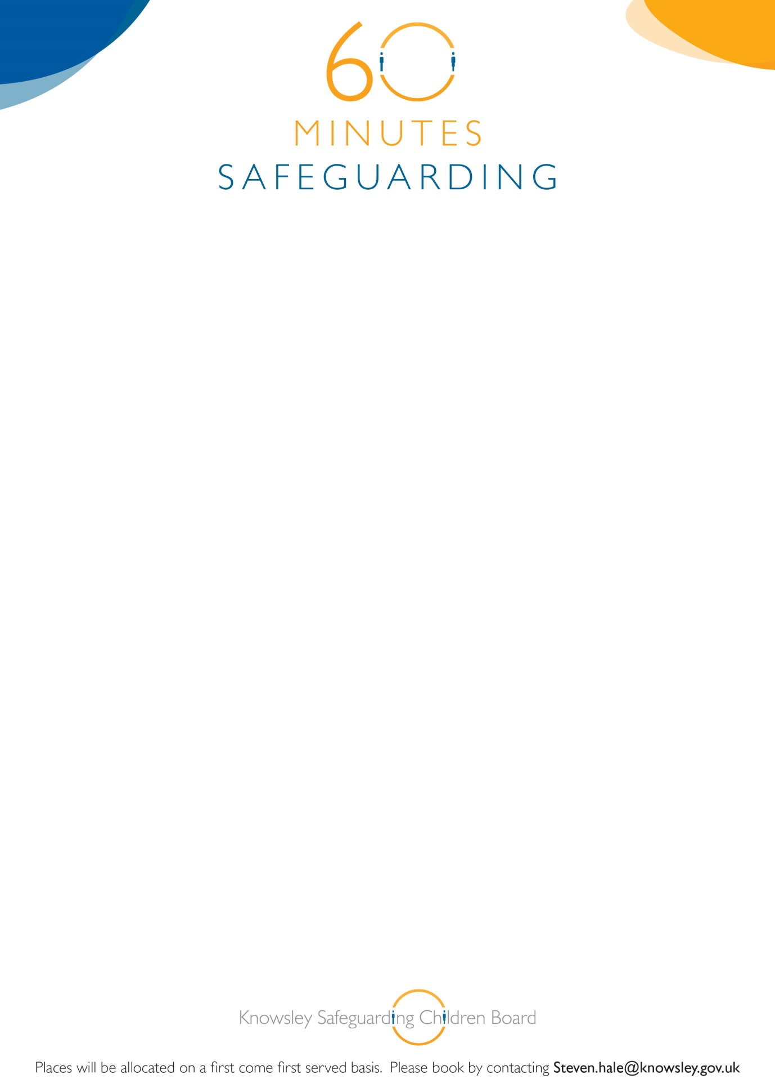

**Knowsley Safeguarding Children Board**

**‘60 Minutes Safeguarding Sessions’**

**Domestic Abuse**

On Wednesday 22nd April

12.00-1.00pm

YOS Training Room

Nutgrove Villa

Westmoreland Road

Huyton L36 6GA

**Booking is essential for this brief but informative awareness session**