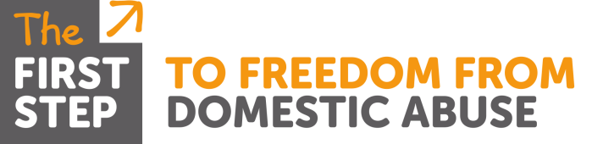

Domestic Abuse Training

Course: Impact of Domestic Abuse on Teenagers
Aimed at: Professionals working directly with teenagers or victims of Domestic Abuse who have teenage children
Trainer: Malka Livingstone
Time: 9.30am – 4.30pm
Date & Venue: TBC
Content: An interactive course with opportunity for participants to reflect, discuss and share their own practice and attitudes towards domestic abuse. The day covers:
- Ways teenagers are affected by domestic abuse
- Identifying healthy, unhealthy and abusive relationships?
- Information teenagers get about relationships
- Grooming & other methods used by perpetrators
- Early warning signs of an abusive partner
- Barriers to seeking effective support
All handouts & attendance certificates will be provided by the Trainer

