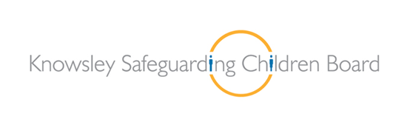

Inappropriate and Harmful Sexual Behaviours Policy and Procedure Launch

As part of our improvement journey and in response to findings from the learning and improvement framework we are launching our new policy and procedure concerning young people who display inappropriate and harmful sexual behaviours.
Date: Monday 14th September 2015 Time: 9:15am: Registration and Refreshments
9:30am – 12:30pm: Launch
Venue:
The Signature Suite
The Venue
Civic Way
Poplar Bank
Huyton
L36 9GD

It is imperative that practitioners who work with children and young people are aware of this policy and of their roles and responsibilities.

Guest Speakers:

Pamela Foster
Operational Manager
Knowsley Youth Offending Service

Steve Bore
Children’s Service Manager
Harmful Sexual Behaviours Therapy and Assessment Service, Barnardos Safer Futures

Part A:
Inappropriate or harmful sexual behaviour is a communication of unmet needs or experience of harm
Research that indicates a level of complexity from an emotional, cognitive and behavioural perspective
The concepts of healthy, inappropriate & harmful sexual behaviours
Part B:
The difference of response for over and under age 10
Working with denial as a coping mechanism
The responsibilities of multi-agency roles

Outline | Item | Speaker
9:15am – 9:30am | Registration and Refreshments
9:30am – 9:45am | Introduction and Setting the Scene | Pamela Foster
9:45am – 10:45am | Part A | Steve Bore
10:45am – 11:00am | Break
11:00am – 11:30am | Part B | Steve Bore
11:30am – 12:15am | Introducing the Policy and Procedure | Pamela Foster
12:15pm – 12:30pm | Questions | Pamela Foster

Please email steven.hale@knowsley.gov.uk to book a place.

