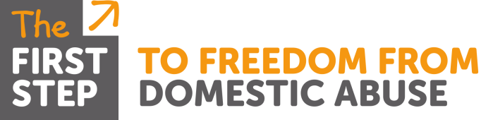

Addressing Domestic Abuse within the
Child Protection Process

Course: Addressing Domestic Abuse within the Child Protection Process
Aimed at: Staff working with children who are on Child Protection Plans where domestic abuse has been identified as an issue
Levels 3 & 4
Three | Members of the workforce who work predominantly with children, young people and/or their parents/carers and who could potentially contribute to assessing, planning, intervening and reviewing the needs of a child and parenting capacity where there are safeguarding concerns | e.g. Paediatricians, GPs, youth workers, those working in the early years sector, residential staff, midwives, school nurses, health visitors, sexual health staff, teachers, probation staff, sports club welfare officers, those working with adults in, for example, learning disability, mental health, alcohol and drug misuse services, those working in community play schemes.
Four | Members of the workforce who have particular responsibilities in relation to undertaking section 47 enquiries. | e.g. Professionals from health, education, police and children’s social care; those who work with complex cases and social work staff responsible for co-ordinating assessments of children in need, practitioner-trainers, DSPs in schools, safeguarding leads

Trainer: Malka Livingstone
Time: 9.30am – 4.30pm
Date & Venue: TBC
Content: An interactive course with opportunity for participants to reflect, discuss and share their own practice and attitudes towards domestic abuse victims and perpetrators. The day covers:
- Methods perpetrators use to gain and maintain control; specifically how they use children in their methods
- Victims response to living with abuse, violence & trauma (Adult & children; including pre-birth) & Coping strategies they may adopt
- Who is responsible for the abuse?
- Methods & reasons perpetrators manipulate workers
- Why victims don’t ‘just’ leave or why they return to abusive relationships
- The role of and the pros and cons of the Freedom & InPact Programme’s
- Safety planning (how to ensure the CP Plan is safe for victims)
- Risk Factors that increase or decrease risk (why it’s important and how to assess risk)
- Good practice when working with victims of domestic abuse

All handouts & attendance certificates will be provided By the Trainer

