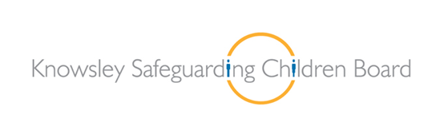

Child Sexual Exploitation Training for Practitioners

Target Group: Level 3 & 4
Three | Members of the workforce who work predominantly with children, young people and/or their parents/carers and who could potentially contribute to assessing, planning, intervening and reviewing the needs of a child and parenting capacity where there are safeguarding concerns | e.g. Paediatricians, GPs, youth workers, those working in the early years sector, residential staff, midwives, school nurses, health visitors, sexual health staff, teachers, probation staff, sports club welfare officers, those working with adults in, for example, learning disability, mental health, alcohol and drug misuse services, those working in community play schemes.
Four | Members of the workforce who have particular responsibilities in relation to undertaking section 47 enquiries. | e.g. Professionals from health, education, police and children’s social care; those who work with complex cases and social work staff responsible for co-ordinating assessments of children in need, practitioner-trainers, DSPs in schools, safeguarding leads

Trainers:
Sarah Herron
Police Representative
Social Care Representative
CSE Team/MASH
Time: 9:30am – 4:30pm
Dates: TBC
Learning Objectives:

By the end of the training participants will be able to

- Have an understanding of the definition of CSE
- Recognise typical indicators and models of sexual exploitation
- Recognise the grooming process

- Identifying the vulnerabilities that lead to CSE
- Identify reporting and referral pathways
- Be clear on how when and why to share information and intelligence
- Discuss ways in which to communicate and engage with vulnerable young people

