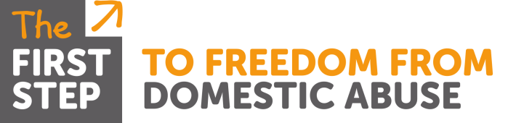

Domestic Abuse Training

Course: First Steps to Understanding Domestic Abuse
Aimed at: Professionals who want to improve their awareness & understanding of domestic abuse
Level 2 & 3
Two (single agency) | Those in regular contact or have a period of intense but irregular contact, with children, young people and/or parents/carers including all health clinical staff, who may be in a position to identify concerns about maltreatment, including those that may arise from the use of CAF/EHA. | For example, housing, hospital staff, YOT staff and staff in secure settings, the police other than those in specialist child protection roles, sports development officers, disability specialists, faith groups, community youth groups, play scheme volunteers, welfare assistants, school crossing patrol
Three | Members of the workforce who work predominantly with children, young people and/or their parents/carers and who could potentially contribute to assessing, planning, intervening and reviewing the needs of a child and parenting capacity where there are safeguarding concerns | Paediatricians, GPs, youth workers, those working in the early years sector, residential staff, midwives, school nurses, health visitors, sexual health staff, teachers, probation staff, sports club welfare officers, those working with adults in, for example, learning disability, mental health, alcohol and drug misuse services, those working in community play schemes.

Trainer: Malka Livingstone
Time: 9.30am – 4.30pm
Date & Venue: TBC
Content: An interactive course with opportunity for participants to reflect, discuss and share their own practice and attitudes towards domestic abuse. The day covers:
- Stats, facts & costs of domestic abuse
- When is a relationship abusive?
- Identifying different types of abuse
- Grooming & other methods perpetrators use to gain and maintain control
- Who is responsible for the abuse?
- Personality traits of a perpetrator of abuse & early warning signs
- The impact on adult victims & coping strategies adopted
- Risk factors
- Why victims don’t ‘just’ leave or return to abusive relationships
- The healing process & ‘Cycle of Trauma’
- Good practice when working with victims of domestic abuse

All handouts & attendance certificates will be provided by the Trainer

