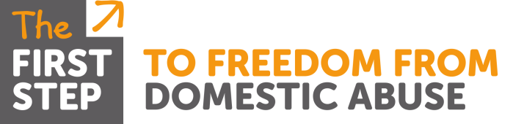
Domestic Abuse Training

Course: Impact of Domestic Abuse on children; pre-birth to 11yrs
Aimed at: Professionals working with victims of DA who are pregnant or have children in this age range or anyone working directly with children
Level 3
Three | Members of the workforce who work predominantly with children, young people and/or their parents/carers and who could potentially contribute to assessing, planning, intervening and reviewing the needs of a child and parenting capacity where there are safeguarding concerns | Paediatricians, GPs, youth workers, those working in the early years sector, residential staff, midwives, school nurses, health visitors, sexual health staff, teachers, probation staff, sports club welfare officers, those working with adults in, for example, learning disability, mental health, alcohol and drug misuse services, those working in community play schemes.

Trainer: Malka Livingstone
Time: 9.30am – 4.30pm
Date & Venue: TBC
Content: An interactive course with opportunity for participants to reflect, discuss and share their own practice and attitudes towards domestic abuse. The day covers:
- The impact & effects of abuse in pregnancy and on a developing foetus

- Identifying 5 stages of child development and exploring how abuse, violence and trauma impact and affect a child’s development in the short and long term

- The links between the impact of domestic abuse and mental health issues later in life

- Healthy and unhealthy coping mechanisms children adopt

- The needs of the children and services available

- Barriers to speaking out or seeking support

All handouts & attendance certificates will be provided by the Trainer

