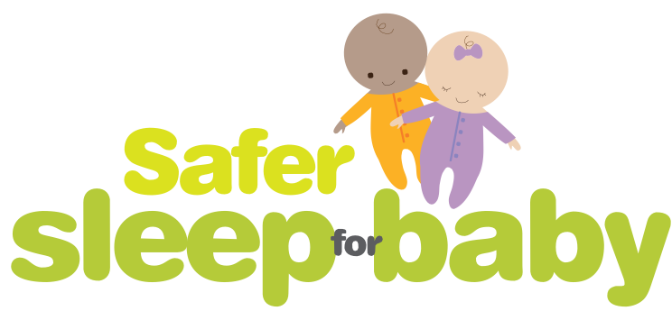

# Follow our

**six steps**

# to safer sleep

Keep baby away from smoke, before and after birth.

**1**

Never fall asleep with baby after drinking or taking drugs/ medication.

**3**

Keep baby’s head and face uncovered and make sure they don’t get too hot.

**5**

Put baby in a cot, crib or moses basket to sleep

**2**

* never fall asleep with them on a sofa or chair.

Put baby to sleep on their back with their feet to the foot of the cot.

**4**

Breastfeed your baby

**6**

* support is available if you need it.

**Together we can reduce the number of babies dying unexpectedly each year.**

[](http://www.knowsleyscb.org.uk/) 

**Originally produced by the Lancashire, Blackburn with Darwen and Blackpool Safeguarding Children Boards**