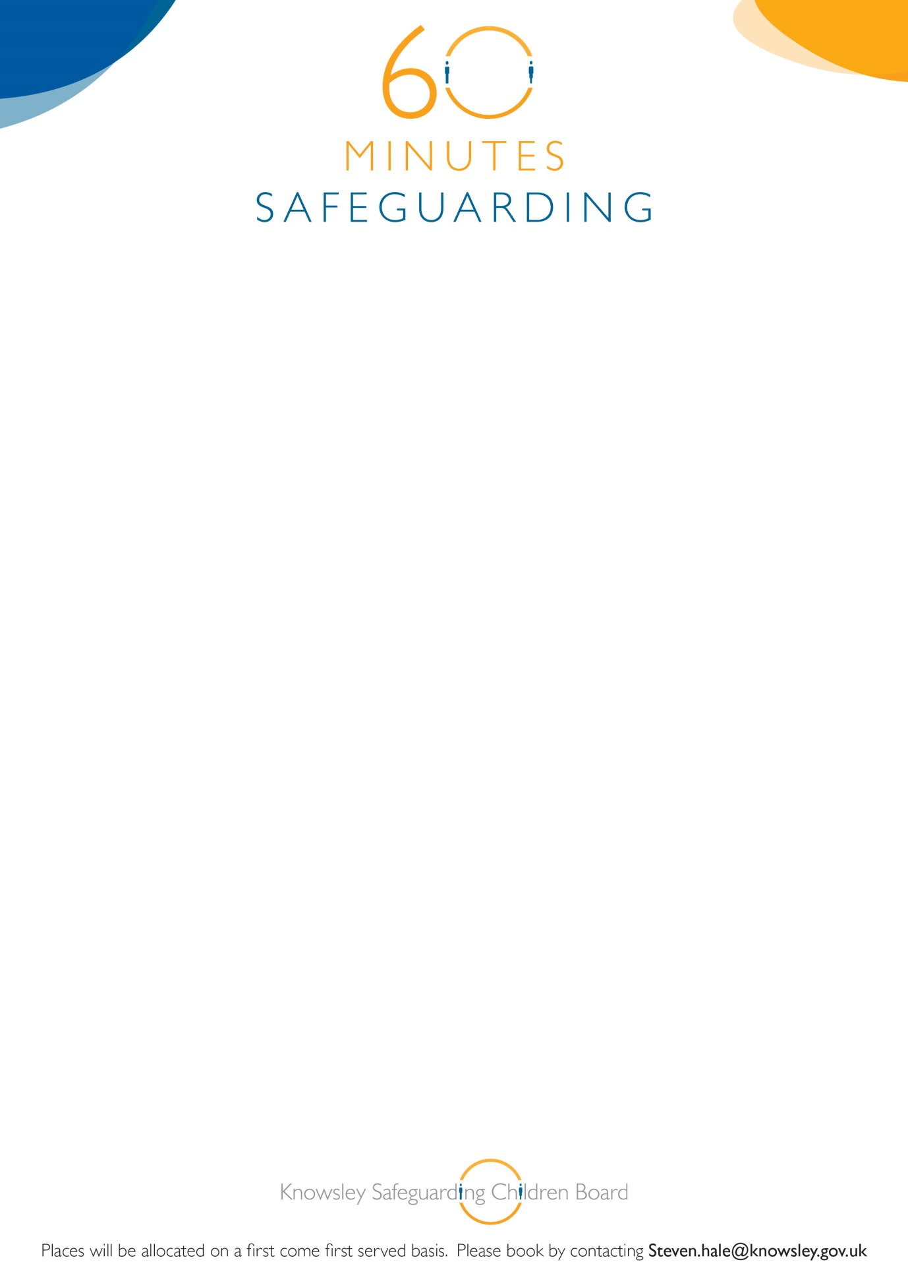

**Knowsley Safeguarding Children Board**

**60 Minute Safeguarding Briefing**

**Strategy Discussions and Section 47 Enquiries (Children Act 1989)**

22nd July 2015

12.00-1.00pm

YOS Training Room

Nutgrove Villa

Westmoreland Road

Huyton L36 6GA

**This briefing is targeted at professionals from all agencies who are likely to contribute to the child protection process.**

**Booking is essential for this brief but informative awareness session. If you book on and are unable to attend, please inform us prior to the briefing or you may be charged. See booking details below:**