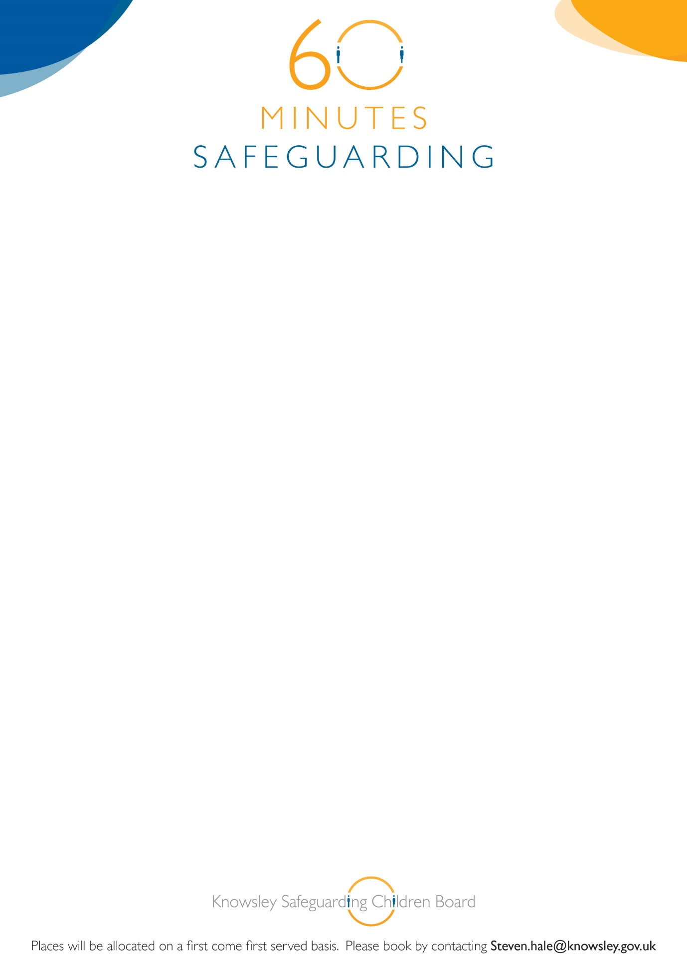

**Knowsley Safeguarding Children Board**

**‘60 Minutes Safeguarding Sessions’**

**Neglect and the Graded Care Profile**

On Wednesday 20th May 2015

12.00-1.00pm

YOS Training Room

Nutgrove Villa

Westmoreland Road

Huyton L36 6GA

**This session is NOT for staff who are attending the one day Neglect and Graded Care Profile (GCP) Training. It is a staff briefing with the aim of giving an overview of Neglect and how the GCP tool can be used.**

**Booking is essential for this brief but informative awareness session. See booking details below:**