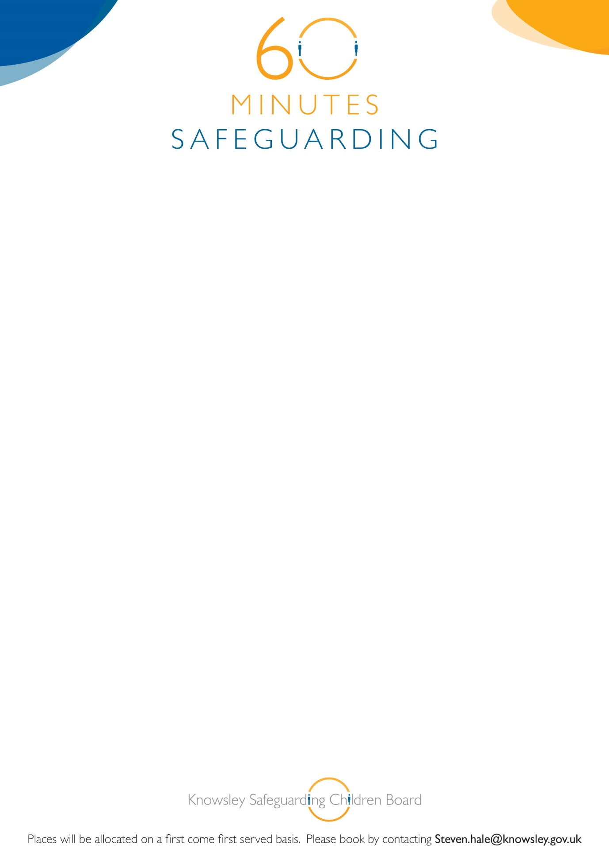

**Knowsley Safeguarding Children Board**

**60 Minute Safeguarding Session**

**‘The Trauma caused by Exploitation’**

19th August 2015

12.00-1.00pm

YOS Training Room

Nutgrove Villa

Westmoreland Road

Huyton L36 6GA

**Karen Hinchcliffe and Suzanne Campbell-Kelly**

**Barnardos**

**Booking is essential for this brief but informative awareness session. If you book on and are unable to attend, please inform us prior to the briefing or you may be charged. See booking details below:**