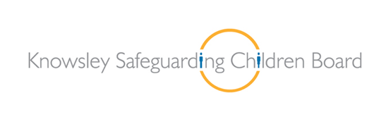
Domestic Violence is a complex issue which can affect anyone of any age or gender. Knowsley Safeguarding Children Board is committed to raising awareness of Domestic Abuse and is taking steps to provide up to date information, key messages and guidance to professionals and young people in an innovative way.
In partnership with Public Health, the KSCB have commissioned Essential Safeguarding and the Mad Theatre Company to showcase the film and drama production ‘Black Eyes and Cottage Pie’. A performance that tells the story of Jodie who is in an abusive teenage relationship with Jordan and how over time this escalating abuse impacts on her life. The play also highlights issues of sexuality, adult domestic abuse, consent, sexting and the power of positive peer relationships.
A plenary session follows the production to highlight the key messages from the play and film and concludes with information of where to get local help, advice and support enabling young people to make informed decision.
Matt Ashton; Assistant Executive Director of Public Health and Wellbeing has highlighted that:
“Unfortunately, we know that 90% of domestic abuse is witnessed by children – they are victims too which is often overlooked. This can include seeing or hearing the abuse, seeing the parent’s injuries or distress afterwards or being hurt themselves as they are nearby or try to stop it. Children may suffer lasting emotional and psychological damage as a result of witnessing domestic abuse. For many children, the scars can last a lifetime. Many don’t know what to do or who to tell because they are scared of what will happen or ashamed about what people will think. That’s why it is essential that we work together with schools to raise awareness of this extremely important issue and ensure children know where to go for help.
This undertaking is essential to ensure we work together in partnership on the prevention agenda for domestic abuse.”
Professionals will initially be given the opportunity to watch this innovative performance. It will then be rolled out to secondary and further education providers across the borough.
This initial showcase will take place on Wednesday 3rd February 2016;
3.00pm Registration (please be prompt)
3:15pm – 4.45pm
The Signature Suite: The Venue, Civic Way, Poplar Bank, Huyton, L36 9GD.
To book a place please contact steven.hale@knowsley.gov.uk. This showcase is targeted at senior staff and pastoral leads within secondary education, councillors, LSCB members, and frontline practitioners from all agencies.
Parking Directions: http://thevenuehuyton.co.uk/wp-content/uploads/2014/03/Conferences-parking-map-with-directions.pdf

