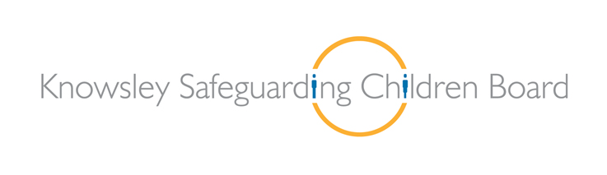
Safeguarding Children & Adults
Alerter Workshop
(Course code: SACBA1)

Wednesday 26th September 2018

The Venue (formerly the Huyton Suite) - Civic Way, Huyton
9.15am - 12.30pm or 1.15pm - 4.30pm
Registration opens at 9.00am for 9.30am start and at 1pm for 1.30pm start

This workshop is recommended for all staff and volunteers in organisations providing or commissioning services to adults, children and families. AftaThought Training Consultants will present case scenarios of adult/child abuse using actors. Attendees will have the opportunity to question the actors in role about their action, or lack of action, in a particular case. The workshop promotes the message that whether you work with adults or with children it is the responsibility of all individuals to recognise and report abuse. The workshop considers barriers to whistle-blowing and how these can be overcome.

Aims of the Day

- To develop a basic awareness of Knowsley’s Multi-Agency Safeguarding Procedures for both children and adults at risk
- To develop an awareness of what your responsibilities are when a child, young person or adult at risk discloses abuse to you
- To develop an awareness of what your responsibilities are when you are concerned that a child, young person or adult is, or may be at risk of, abuse or neglect
- To understand what you must do and what you must not do
- To understand the circumstances in which confidential information must be shared

Applications to:
Email: Workforce.DevelopmentTeam@knowsley.gov.uk
When booking please include the name of delegate, their role, the name of the organisation, telephone contact number and manager’s name.

Parking: Attendees should park in the long stay parking facilities at Club 3000 Bingo, Poplar Bank L36 9US or Levels 3-7 of the multi storey facility on Lathom Rd L36 9YB or Huyton Hey Rd care park (next to McDonalds) L36 5SE.
Please ensure that your staff are aware of this information.
Please note that this course is FREE but charges may be made for non-attendance.

