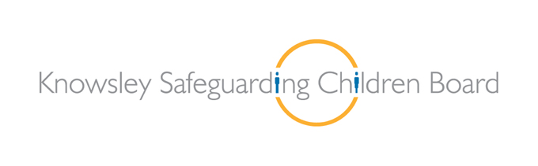

Knowsley Multi-Agency Child Exploitation Policy and Guidance

January 2019


Document Owner: Pamela Foster, Shield Coordinator
Review date: January 2021
Contents
Section 1 Background page 4
1.1 Introduction
1.2 Why do children become involved
1.3 Scope

1.4 Policy aims and purpose
1.5 Definitions
1.6 Language
1.7 Child Exploitation (CE) Police Coordinator
1.8 CE Champions
1.9 Knowsley’s SHIELD (Child Exploitation and Missing) Team
Section 2 Safeguarding page 11
2.1 Signs of exploitation
2.2 What to do if you are worried about a child being at risk of Exploitation
2.3 Child Exploitation MACE pathway
Section 3 MACE page 14
3.1 MACE Terms of Reference
3.2 MACE
Section 4 - CE2 and lead practitioners’ plans page 17
Section 5 – Transfers, step up and down, non-engagement & closure page 18
5.1 Children open to the MACE transferring to other authorities
5.2 Step up and down of Knowsley children
5.3 Non engagement of Knowsley children
5.4 CE 2 and plans not being completed within timescales
Section 6 – Key pieces of Guidance to assist with Assessment and Planning page 20
6.1 Contextual Safeguarding Network
6.2 Trauma Recovery Model
6.3 Support in Children’s Residential Homes
6.4 Child exploitation models and push and pull factors
6.5 Shield Interventions and Consultations
Section 7 - Information Sharing Agreement page 23

Section 8 Where an agency has soft intelligence page 23

Section 9: Complaints Procedure page 23

Appendix A – MARTHR referral form

Appendix B - Police MACE preparation template

Appendix C - Merseyside Child Exploitation 1 (CE1) referral Form

Appendix D - Things to consider in a strategy meeting

Appendix E- Merseyside Child Exploitation 2 (CE2)

Appendix F - Child’s notification of placement with CSE or CCE concerns
Appendix G - Pan Merseyside Information Sharing Agreement

Appendix H – Flowchart of key questions for information Sharing

Appendix I - Shield intelligence/information form

1. Section 1: Background
1.1 Introduction
All agencies across Knowsley are fully committed to safeguarding children from being sexually or criminally exploited, whilst disrupting the prosecuting the individuals who have exploited them. This policy provides a set of multi-agency principles for tackling Child Exploitation. An overarching term of Child Exploitation (CE) will be used throughout this policy to encompass both criminal and sexual exploitation of children in our area.
The Policy details how through the Multi-Agency Child Exploitation meetings (MACE) we can reduce the harm posed to children from Child Exploitation.
Child Exploitation, whether sexual or criminal, is child abuse. Children who become involved face huge risks to their physical, emotional and psychological health and well-being.
1.2 Why do children become involved?
The common issues and reasons can be due to a number of factors, including vulnerabilities identified and being targeted by the abuser. It is often the case that children do not perceive themselves to be victims, as they consider they have acted voluntarily. The reality is that their behaviour is not voluntary or consenting.
Children who run away or go missing from home, care or education are recognised as being more at risk of being targeted as a victim of exploitation. Evidence is clear that a missing child is believed to be at risk from Child Exploitation, irrespective of the length of time they are away from home or a caring environment (Plass, 2007; CEOP, 2011b).
1.3 Scope
These procedures relate to:
- Children looked after by Knowsley Metropolitan Borough Council, placed in either foster care, local authority or privately run children’s homes within or outside the borough of Knowsley.
- Children looked after by responsible councils outside of Knowsley, placed with care providers within Knowsley.
- Children who reside in Knowsley.
- Perpetrators of Child Exploitation that reside in Knowsley.
For the purposes of this policy; a child is defined as anyone who is under 18 years of age. Care leavers can comprise of children from 16-24 years of age.
Knowsley Borough Council retains responsibility for Knowsley children looked after who are placed outside the local authority boundaries. In these cases Knowsley Children Social Care (CSC) will require the placement provider to comply with this protocol and those local to their area.
This policy should be read alongside and other responsible authorities placing children within Knowsley boundaries will be required to comply with:
- Pan Merseyside Missing Children Procedure. May 2018
- Knowsley Missing Policy. January 2019
- Pan Merseyside Multi-Agency Child Exploitation Protocol 2018

This policy is in line with three of KSCB Strategic Priorities:
- Children in Knowsley are safeguarded and protected from harm, including abuse, neglect and exploitation.

- The voices and experiences of children are fully embedded in practice and service planning.

- That children in Knowsley are safeguarded from exploitation including child sexual exploitation.

This guidance should be read alongside Knowsley Local Safeguarding procedures and it is not intended to replace other actions that workers may take to safeguard children.
1.4 Policy aims and purpose
This policy seeks to unify a process of recognition, risk assessment, referral and discussion amongst professionals utilising a single process and document set for all. This policy sets out a clear pathway by which to ensure all organisations unify to provide the best service possible for all children who are at risk of being exploited.
The aims and purpose of the procedures are to:

- Identify those who are at risk of being sexually and/or criminally exploited, by sharing information at an early stage using the Pan Merseyside Child Exploitation (CE1) referral and assessing risk using the Pan Merseyside Child Exploitation Multi-Agency Assessment Tool (CE2).

- To provide appropriate management and governance oversight of these vulnerable children.

- Apply pro-active problem solving to address the risks associated with victims, perpetrators and locations and to ensure the safeguarding and welfare of children who are or may be at risk from exploitation.

- Take proactive action against those who are intent on sexually or criminally abusing and exploiting children and young people.

- Ensure timely and effective interventions are offered to children and families so as to safeguard those vulnerable to exploitation. Ensure partnership agencies work collaboratively to safeguard children who are being, or are at risk of being exploited.

- Promote positive physical and emotional health and well-being of individuals identified as being at risk of child exploitation by ensuring appropriate therapeutic, sexual health and pre-trial therapy support is available to those children who have experienced exploitation.

- To use data and intelligence to develop an understanding of child exploitation taking place across Merseyside, implement disruption tactics and ensure services are commissioned which can meet identified need.

1.5 Definitions
Child Sexual Exploitation
Child Sexual Exploitation is a form of child sexual abuse. It occurs where an individual or group takes advantage of an imbalance of power to coerce, manipulate or deceive a child under the age of 18 into sexual activity:
(a) In exchange for something the victim needs or wants, and/or
(b) For the financial advantage or increased status of the perpetrator or facilitator.
The victim may have been sexually exploited even if the sexual activity appears consensual. Child Sexual Exploitation does not always involve physical contact; it can also occur through the use of technology.
(Home Office 2017)

Child Criminal Exploitation
Child Criminal Exploitation occurs where an individual or group takes advantage of a person under the age of 18 and may coerce, manipulate or deceive a child under that age into any activity

(a) In exchange for something the victim needs or wants, and/or
(b) For the financial advantage or increased status of the perpetrator or facilitator and/or
(c) Through violence or the threat of violence.

The victim may be exploited even if the activity appears consensual (i.e. moving drugs or the proceeds of drugs from one place to another). Child Criminal Exploitation does not always involve physical contact; it can also occur through the use of technology. (Home Office 2018)

County Lines
County lines is a term used to describe gangs and organised criminal networks involved in exporting illegal drugs into one or more importing areas (within the UK), using dedicated mobile phone lines or other form of “deal line”. They are likely to exploit children and vulnerable adults to move (and store) the drugs and money and they will often use coercion, intimidation, violence (including sexual violence) and weapons. (Home Office 2018)
County lines is a form of Child Exploitation (CE). It is a major, cross-cutting issue involving drugs, violence, gangs, safeguarding, criminal and sexual exploitation, modern slavery, and missing persons. The response to tackle it involves the Police, the NCA (National Crime Agency) and a wide range of Government departments, local government agencies and VCS (voluntary and community sector) organisations. County lines activity and the associated violence, drug dealing and exploitation have a devastating impact on children, vulnerable adults and local communities.
Cuckooing
Urban gangs establish a base in the market location, often by taking over the homes of local vulnerable adults by force and/or coercion, in a practice referred to as ‘cuckooing’. Urban gangs then use children and vulnerable people to move drugs and money.

Modern Slavery Act 2015

Section 2 Human Trafficking
A person commits an offence if the person arranges or facilitates the travel of another person to exploit them. It is irrelevant whether the exploited person, adult or child, consents to the travel. A person may, in particular, arrange or facilitate another person’s travel by recruiting, transporting or transferring, harbouring or receiving them, or transferring or exchanging control over them.

‘Travel’ means arriving in, or entering, any country; departing from any country and travelling within any country. A person who is a UK national commits an offence under Section 2 regardless of where the arranging or facilitating takes place, or where the travel takes place.
A person who is not a UK national commits an offence under Section 2 if any part of the arranging or facilitating takes place in the UK, or the travel consists of arrival in or entry into, departure from, or travel within the UK.
In determining whether or not a child is a victim of trafficking, their consent to being trafficked is irrelevant and how they are trafficked is also irrelevant. Only the act and the purpose need to be present. It is not necessary to prove coercion or any other inducement.
Exploitation alone does not constitute trafficking – there also needs to be recruitment, transportation, transfer, harbouring or receipt of a person.
Slavery, servitude and forced or compulsory labour is, or may be, a crime in its own right under Section 1 Modern Slavery Act 2015.
Contextual Safeguarding (Firmin, 2017)
Contextual Safeguarding is an approach to understanding, and responding to, young people’s experiences of significant harm beyond their families. It recognises that the different relationships that children form in their neighborhoods, schools and online can feature violence and abuse. Parents and carers have little influence over these contexts, and young people’s experiences of extra-familial abuse can undermine parent-child relationships. Therefore children’s social care practitioners need to engage with individuals and sectors who do have influence over/within extra- familial contexts, and recognise that assessment of, and intervention with, these spaces are a critical part of safeguarding practices. Contextual Safeguarding, therefore, expands the objectives of child protection systems in recognition that children are vulnerable to abuse in a range of social contexts.
The Multi-Agency Child Exploitation meeting (MACE)
Child Exploitation takes places in local communities and information known to the full spectrum of statutory and voluntary sector agencies should be used to highlight the threat, establish and reduce risk. It is anticipated that an improved intelligence picture will enable effective action in a greater number of cases of child exploitation, thereby reducing the harm that would otherwise be caused to the young victims and their families.
A MACE meeting will provide the framework to allow regular information sharing and action planning to tackle child exploitation across Merseyside. Representatives from a range of statutory, voluntary and community sector agencies will attend at the meeting. The MACE meetings will be co-chaired by Merseyside Police (usually a Detective Inspector) and Safeguarding lead for the Local Authority.
Multi-Agency Response to Threat, Harm and Risk (MARTHR)
Children Services work closely with community police and safety partners and attend a monthly Multi-Agency Response to Threat Harm and Risk meeting (MARTHR), alongside adult service partners. MARTHR is jointly chaired between the council and Merseyside Police and is responsible for considering those alleged perpetrators for criminal and sexual exploitation of children. The Community Safety Partnership further facilitates a problem solving forum. This forum allows agencies to refer particular locations or individuals for discussion at a senior multi-agency level and plans are developed utilising all different agencies powers in order to reduce risks. At any stage an adult perpetrator’s name becomes apparent then a referral needs to be made into MARTHR process (See appendix A)
1.6 Language
Language is an important part of how we identify and assess exploitation. Guidance on language agencies should use to describe a child’s situation and behaviour:
“He/she is drug running” | The child is being trafficked for the purpose of criminal exploitation
“Recruit/ run/ work” | This implies there is a level of choice by the child regarding their exploitation and does not take into consideration the grooming, coercion, threats and violence. More appropriate description:  The child is being criminally exploited.
“He/she is choosing this lifestyle” | This implies choice or control by the child. More appropriate description:  The child is being criminally exploited.
“Putting themselves at risk” | This implies choice or control by the child. More appropriate description:  The child is being criminally exploited.
“Promiscuous” | This puts the blame on the child and implies the child is in full control of what is happening. More appropriate description:  The child is either being exploited or vulnerable to exploitation.
“Involved in CSE or CCE” | This implies choice or control by the child. More appropriate description:  The child is being exploited.
“Sexually active since (age under 13)” | The child has been sexually assaulted or raped.
“Streetwise” | This implies the child is able to able to keep themselves safe and is fully able to manage situations that present risk.

1.7 Child Exploitation (CE) Police Coordinator
The CE Police Coordinator is responsible for:
- MACE preparation:
- read all the CE 2 forms
- make additional enquires on any significant information contained in the CE 2 forms
- ensure any relevant information is submitted as intelligence on police systems
- complete the police MACE preparation template (see appendix B)
- MACE attendance, contribution and take actions from the MACE
- To update the MACE with any intelligence or hotspot information including Force Intelligence Bureau (FIB) CE briefings
- Manage CE flags on Niche
- Ensure transition of the CE 2 for all children moving in and out of Knowsley to other MACE processes
- Ensure all high risk CSE and CCE have a CE trigger plan
- Ensure all CE 2 are on police systems
1.8 CE Champions
There are CE champions across the threshold model of services:
- CP and CLA teams
- Family First
- YOS
- Early Help level 2.
These champions are each team’s single point of contacts for discussion before submitting a CE 2 assessment into MACE and formulating lead practitioners plans. The CE Champions will receive regular training and support via Shield.
1.9 Knowsley’s SHIELD (Child Exploitation and Missing) Team
Shield is a multi-agency team to protect children against child exploitation. The Shield Team’s vision is to keep children safe and free from exploitation by being a centre of excellence.
The Shield team aims to work together with children, families and the community to offer a range of services to reduce the risk of child exploitation by
- Providing a central point for all professionals to receive expertise with reference to child exploitation.
- Providing a coordinated and proactive response to dealing with child exploitation: prevention, safeguarding and prosecution.
- Reducing and preventing children from being exploited and reduce the number of episodes of children going missing.
- Promoting the development of positive relationships with children and their families affected by exploitation
- Improving evidence gathering and information sharing to inform problem profiling and prosecutions.
The Shield Team
Telephone; 0151 443 5028
Email: Shield@knowsley.gcsx.gov.uk
Egress email: Shield@knowsley.gov.uk 

Section 2 Safeguarding
2.1 Signs of exploitation
There are common vulnerability factors in children that can lead to them being more likely to be exposed to exploitation, and common signs and behaviours displayed by those who are already being exploited. Some of the signs are:
- Absent from school
- Staying out late/overnight
- Regularly missing
- Unexplained gifts/new possessions
- Drugs and alcohol use
- Secretive behaviour
- Offending behaviour
- Inappropriate or sexualised behaviour
- Significant changes in mood or behaviour
- Becoming withdrawn or isolated
- Changes in appearance (clothes, hygiene etc.)
- Mental health changes / self-harm
- Excessive time spent on social media talking to “friends” they haven’t met.
- Pregnancy, terminations or repeat testing for sexually transmitted infections
- Child has been coerced to take/share images
- Being found traveling to an unfamiliar area
- Multiple mobile phones
- Family or child having to leave the home
- Items missing from home
- Child is carrying/concealing weapon
- Association with others who have been exploited
- Injuries
- Family breakdown
- Homeless
- Child has limited age-appropriate friendships

2.2 What to do if you are worried about a child being at risk of exploitation.
If a child is presenting with signs of being exploited then a Multi-Agency Referral Form (MARF) must be completed on line https://marf.knowsley.gov.uk/Home and a Child Exploitation 1 (CE1) (see appendix C) to be sent into Knowsley Multi-Agency Safeguarding Hub which is then screened in MASH and the CE 1 is forwarded to the Shield Team.
If a child is open to Knowsley Children Services then the social worker will screen the safeguarding referral/concerns. If the child is not open to Children Services then the MASH will screen the MARF. A decision will then made to the level of presenting need and refer the child to the appropriate level of service if required:
- No further action
- Signposting
- Early Help
- S17 Initial assessment
- S47 Child Protection

If the decision is made that a Strategy Meeting is required then further considerations are required in addition to the standard strategy meeting format (See Appendix D). If the child is open to Knowsley children services then the relevant team manager will chair the strategy meeting. If this child is not open to Knowsley children services then either the Mash team manager or Shield Coordinator will chair the strategy meeting.
If the child has been placed in Knowsley by any other responsible authority the MASH/Shield will contact the responsible authority to ascertain what action is being taken and if a strategy meeting is required then MASH/Shield will assist with any arrangements required to enable the responsible authority to chair the strategy meeting. If the responsible authority refuse to chair the strategy meeting then MASH/Shield manager will arrange and chair the strategy and the responsible authority will be expected to attend at the date and time convened. In exceptional circumstances it may be agreed between Knowsley and the responsible authority that a strategy meeting is not required (ie legal planning meeting or secure applications are in progress). In these circumstances discussion needs to take place between MASH/Shield and the responsible social worker to clarify who is going to inform the care home of any relevant information in relation to risk concerns.
If there are no immediate safeguarding concerns and a child is open with Knowsley Social Care, Early Help Services or the Youth Offending Service then the referrer completes the CE1 on liquid logic and sends to the Shield tray.
2.3 Child Exploitation MACE Pathway
The Shield team has a daily morning briefing and the CE 1 is discussed to determine whether appropriate safeguarding or police actions are being completed or further action is required. Each week the Shield Detective Sergeant and the Shield Coordinator will review the information in the CE1 and make a decision on whether the referral should progress to Multi-Agency Child Exploitation (MACE) meeting. Things that are taken into consideration when making the decision to progress to MACE:
- Is it exploitation?
- Back ground and history
- Associations
- Level of protective and risk factors
- Warning signs of exploitation
- Does this require a full CE 2 assessment under MACE or can a single agency provide the required intervention (e.g online safety work in school)

If it is decided that the CE 1 referral does not need to proceed to MACE then the rationale will be recorded on liquid logic and Niche and the referrer will be informed. If it does reach the threshold for MACE then the following will take place:
- Any immediate actions will be written on CE 1 form which will be saved onto Niche and liquid logic and a CSE or CCE flag will also be placed on both systems. Consideration of whether a National Referral Mechanism referral is required and actioned. www.gov.uk/government/publications/human-trafficking-victims-referral-and-assessment-forms

- The Shield team will start the CE 2 on liquid logic and assign it to the lead practitioner’s work tray to complete and to update their plan within a multi-agency meeting of all professionals working with the family by a certain cut-off date. If the child is placed in Knowsley by another responsible authority then a blank CE 2 word document (see appendix D) will be sent to the responsible social worker to complete in a set timescale. Any assistance required in completing the CE 2 tool then please contact the Shield team.

- If CSE is the main concern then a police detective from the Shield team must be included in the completion of the initial CE2. Please email Shield@knowsley.gcsx.gov.uk to request attendance.

- If CCE is the main concern then police should be included in the completion of the CE 2, if they cannot attend the meeting then there needs to be some form of consultation with Police prior to the meeting. If the child is open to YOS then the YOS police officer can attend. If no YOS involvement, please email the Community Hub 7 days before the meeting. Email address is: C.Community.Hub.1@merseyside.pnn.police.uk. If the child attends a school with an attached schools officer then please highlight this on the email.

- For Knowsley young people, once the CE2 is completed then the lead practitioner must consult with their CE champion in their team to ensure the CE 2 assessment and plan is to the required standard to be submitted to MACE. (quality standards required for CE2 and plans detailed in section 4)

- The lead practitioner then must assign the CE 2 into the MACE tray on liquid logic. For children placed in Knowsley the responsible social worker should email the CE 2 back to Shield via secure email address and Shield Business support will then input the CE 2 word documents into liquid logic on EHM.

- Shield will then send out the CE 2 and the lead practitioners plan to all MACE representatives seven days prior to the MACE

Section 3 MACE
3.1 MACE Terms of Reference
Group |  | Knowsley Multi-Agency Child Exploitation (Sexual and Criminal Exploitation)
Chair |  | Jointly chaired by Knowsley Senior Conference (safeguarding lead) and Reviewing Officer and Merseyside Police Inspector.
Core membership
 | Shield |  | Knowsley Council
 | Child Protection Teams |  | Knowsley Council
 | Early Help Service |  | Knowsley Council
 | YOS Health |  | YOS
 | Sexual Health |  | Health
 | Community Policing Inspector |  | Merseyside Police
 | IOM police |  | Merseyside Police
 | Looked After Health |  | Health
 | Youth Offending Service |  | Knowsley Council
 | Looked After Teams |  | Child Team
 | Voluntary sector CE Worker |  | Catch 22
 | Whiston Hospital |  | Health
 | Safeguarding lead |  | Education
 | CE Coordinator |  | Merseyside Police
 | Voluntary drug and alcohol services |  | CGL
 | Case Manager |  | Safer Communities
 | Knowsley Youth Mutual |  | Youth Service
 | CAMHS worker |  | CAMHS
 | RASAC worker |  | RASAC
Purpose
The aim of the MACE is to provide a framework and governance to promote a clear consistent response to concerns in relation to child exploitation in Knowsley.
Key Objectives
The MACE provides:
- A framework to allow regular information/intelligence sharing and action planning to tackle CE from a range of statutory, voluntary and community sector agencies,
- A governance structure to ensure all concerns about child exploitation have been assessed and responded to appropriately via safeguarding and enforcement agencies,
- A quality assurance process of the standard of the CE2 assessment and that CE identified needs have been responded to via the lead practitioners plan,
- A forum identify and respond to gaps in provision and to escalate any enforcement or safeguarding concerns,
- A meeting to share wider intelligence sharing of the CE risks and needs across Knowsley
- A process to identify any child who presents as a victim of exploitation and also a risk towards other children to ensure risk is identified and managed appropriately (MACE part B),
- To identify any child turning 18 who is vulnerable to exploitation or any CE perpetrators living in Knowsley who require a referral to Multi-Agency Response to Threat, Harm and Risk (MARTHR)
The MACE meeting will not supplant, replace or override current safeguarding procedures. Cases involving children who are at immediate risk, should not wait for the MACE meeting.
Governance
The MACE will report/ escalate to the Muti-Agency Child Exploitation (MACE) and Missing Performance Board on a quarterly basis.
The MACE safeguarding lead chair will escalate any safeguarding concerns within Knowsley council or other responsible authorities and the MACE police lead chair will escalate any enforcement/police concerns within Merseyside Police.
Role of members
Members of the meeting will be responsible for the Multi-agency oversight of all CE 2 and lead practitioner’s plans.
Members are expected to read all the paperwork that is sent out one week before MACE and attend the MACE to express individual agencies opinion on:
- Any missing information
- Whether the risk level is deemed appropriate
- The standard of assessment and plan being appropriate

Members are also expected to:
Be the single point of contact for agencies for CE by:
- Ensuring information or actions are disseminated within own agency / department / team and to other partners as relevant
- Active participation in agenda and discussion, bringing issues to and from own area of responsibility.
- Undertaking actions as agreed by the meeting
- Raising any concerns of lead practitioners
- Abiding by the Information Governance guidelines for each agency and Data Protection Act

If a nominated member of the meeting is unable to attend, then a designated representative should attend in their place. The nominated delegate will be identified in advance and should be of an appropriate level to undertake decisions on behalf of the nominated member and their organization. The nominated member should ensure that their designated representative has been briefed and provided with the relevant papers.
Frequency
Meetings for CSE will be bi-monthly and meetings for CCE will be monthly unless demand increases

3.2 MACE
The MACE is jointly chaired by Knowsley Senior Conference (safeguarding lead) and Reviewing Officer and Merseyside Police Inspector. If either cannot attend the MACE meeting then a designated representative should attend in their place to ensure joint cover of safeguarding and police enforcement. On the rare occasions, if both chairs are unable to chair then this will fall to the CE local authority lead in the council.

The MACE has a set agenda which includes: new CE referrals, review of existing CE2 every three months, intelligence and hotspots for CSE or CCE. The MACE agenda also a PART B which includes further examination of those children who are victims of exploitation but also present a risk towards others.
MACE representative’s responsibility is to ensure that the CE 2 assessment and lead practitioners’ plan is relevant and up to date and that review information has been captured and evidences risk levels.
If MACE representatives do not raise any questions/objections at the MACE, then the risk level will be agreed and the case will not be discussed any further and a review date will be set. If there is missing information or disagreement with the risk level and plan then the MACE representative for your agency will feedback what was discussed. Shield will be the representative for children placed in Knowsley by other responsible authorities. Details of the MACE decision on risk level and comments will be recorded on the MACE section of the CE tool and will be saved on liquid logic and Niche.
All children assessed as medium or high will remain on a CE database and a request to review the CE 2 will be sent every three months unless MACE overrides this time period. If there is a significant change then the CE 2 tool should be reviewed earlier than 3 months.
If a child is assessed as high risk of CE for more than six months then the Shield Coordinator will complete a review of the case with the relevant professionals to establish whether any additional resources are required or the existing CE intervention requires adapting to reduce the risk.
When the MACE agrees the risk level is low and the investigation has ceased then Shield will remove the CSE and CCE flags on Niche and liquid logic. A repeat CE referral is defined as when a child is no longer in the MACE process and a new CE 1 has been submitted which is progressed through to the MACE. The Shield Coordinator will complete a review of the case to establish whether there is any learning identified and will feedback findings to the MACE and Missing Performance Board.
On occasion the MACE may identify that a location is becoming an increasing concern and the MACE can then decide whether that particular location requires a referral into the Location Problem Solving Meeting which is chaired by Safer Communities. If a group is becoming an increasing concern then the MACE can then decide whether additional analysis and mapping is required and whether the Shield Coordinator or the MACE chairs need to convene a separate meeting with all the lead practitioners and relevant agencies.
During the MACE consideration will be given on whether a MARTHR referral is required for:
- a CSE or CCE perpetrator residing in Knowsley,
- a child who is turning 18 years old and still vulnerable to criminal exploitation, or
- a child who presents with no current intelligence or evidence of exploitation but is believed to be involved in offending and Integrated Offender Management (IOM) service may be required.

Section 4 CE2 and lead practitioners’ plans
The Pan Merseyside CE 2 assessment tool has been designed to enable analysis on key factors to establish areas requiring intervention. The CE 2 will be subject to review and changes under the Strategic Pan Merseyside MACE.
The CE 2 must be completed in a multi-agency meeting with all key partners. Practitioners can use their existing multi-agency forums to complete and review the CE 2 such as CIN, Core Groups, Team Around the Family or Youth Offending Service meetings. The views of the child and their family must be sought to inform the assessment.
If there are concerns identified regarding compromised parenting and the parent/carer is believed to be part of the exploitation, the Knowsley safeguarding procedures must be followed.
If any significant intelligence / safeguarding concerns are identified before the due review date a multi-agency meeting must be reconvened to discuss the new information and the CE 2 must be re-considered and updated accordingly. If there are significant harm concerns this meeting must be convened as a Strategy meeting.
Following completion of the CE 2 assessment a multi-agency discussion is required on whether the lead practitioners’ plan addresses the findings of the assessment: ways to strengthen the child’s resilience and protective factors as a form pulling them away from the exploitation risk and address any risk concerns utilising contextual safeguarding approaches. (see section 6 for further guidance)
When completing a review of a CE 2 the old and new information in the evidence boxes needs to be dated and risk levels changed accordingly. It is important to keep the old information in the CE 2 so that it reflects the progress being made. If direct work is being completed in relation to CE then the worker responsible is expected to provide to the lead practitioner a report of the work completed and an analysis of the progress and future plans so this can be reflected in the CE 2 and lead practitioners’ plan.
All Knowsley practitioners must hold a discussion with the CE Champion on their team to ensure the initial and review CE 2 have been completed to the standard required:
- Evidence is captured to support risk levels
- The CE 2 has been completed in a multi-agency forum
- All plans reflect the identified protective and risk factors identified in the CE 2
- All review CE 2 and plans have been updated to capture the work being completed including an analysis of progress and any future plans.
- If non-engagement is a key factor then all methods of engagement have been evidenced.

Section 5 – Transfers, step up and down, non-engagement and not completing CE 2 within timescales.
5.1 Children open to the MACE transferring to other authorities
If a Knowsley child moves address to reside in another authority then the CE Coordinator should contact the CE Coordinator in that area to ensure a transfer takes place from Knowsley MACE to the other authorities MACE process.
If the Knowsley child is a child looked after and remains the responsibility of Knowsley Children Services the same process should take place with the CE Coordinator arranging a transfer however the child will also remain in Knowsley MACE process for oversight.
If a child is placed in Knowsley then a notification of placement should be sent to knowsleyMash@Knowsley.gcsx.gov.uk alongside all relevant CSE or CCE assessment and information. Once Shield has received a notification and there are identified CE concerns, Shield will contact the responsible authority to arrange a meeting to discuss the concerns and provide the lead practitioner with the Pan Merseyside CE 1 & 2 (see Appendix F). The responsible social worker can then send back to Shield@knowsley.gcsx.gov.uk the completed CE 1 & 2 and a copy of the care plan so that the child can be included in the Knowsley MACE for oversight.
If a child who is placed in Knowsley by another responsible authority moves from Knowsley then it is the responsible social workers responsibility to notify agencies in that area. If the Knowsley CE Coordinator is informed of the new address then the CE Coordinator will notify that area that the child has been in Knowsley MACE process.
5.2 Step up and down of Knowsley children
If the child is assessed as medium or high on the CE 2 then the child cannot be closed to services as a lead practitioner is required.
If the child is being transferred via step up or down procedures then the Shield Team must be notified who will be the lead practitioner via email. Shield@knowsley.gscx.gov.uk . If there are any difficulties with the step up or down procedures then please inform the Shield Coordinator so that further discussions can take place with CSC and Early Help managers. The CE 2 will then need to be reviewed at the MACE so that a decision can be made in relation to whether escalation is required.
It is the responsibility of all professionals involved with a child and/or their family, regardless of risk level, to ensure that the appropriate steps are adhered to. If there are irresolvable barriers to this, then the usual escalation policy applies.
5.3 Non engagement of Knowsley children
Often with CSE and CCE the risk of harm is from an extra- familial context and contextual safeguarding approaches are required. A key barrier for agencies can be the child or families’ non-engagement which can be a further indicator that there is current exploitation taking place. If the child is assessed as medium or high risk of CE then all different forms of engagement should be utilised: different style of engagement, different workers, trying to engage with key individuals within the family, utilising the voluntary sector or other agencies to assist with engagement with the child.
If all forms of engagement have been tried then the CE 2 needs to be updated to reflect those attempts at engagement so that the MACE can decide what further action is required.
5.4 CE 2 and plans not being completed within timescales
If a lead practitioner is unable to complete the CE 2 in timescales requested then please email Shield business support via Shield@knowsley.gcsx.gov.uk and Shield can move the child to the following MACE meeting.
If the CE 2 is still not completed the following month then the Shield Coordinator will notify the lead practitioner’s team manager. If another responsible authority has not completed the CE 2 in timescales requested, then the Shield Coordinator will escalate to Knowsley Quality Assurance Unit so that an escalation letter can be sent to the responsible authorities Quality Assurance Unit.
Section 6 – Key pieces of Guidance to assist with Assessment and Planning
6.1 Contextual Safeguarding Network has very useful tools and research on responding to contextual safeguarding concerns: school, peers and neighbourhood risks. www.contextualsafeguarding.org.uk
6.2 Trauma Recovery Model to assist with sequencing of CE interventions recognising what stage the child is currently at and how services can response to presenting needs. www.traumarecoverymodel.com

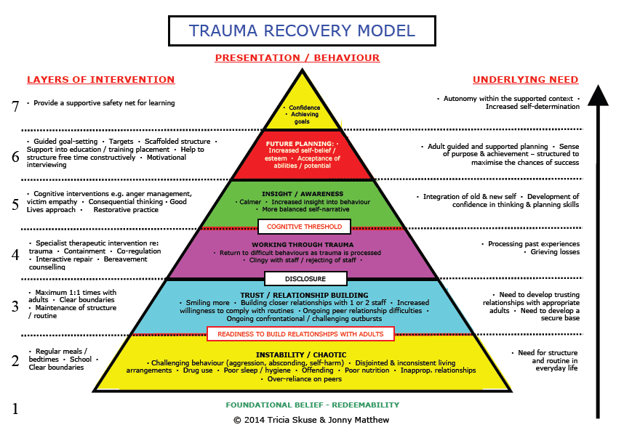

6.3 DfE CSE: Support in Children’s Residential Homes. Dec 2016 Ivana La Valle & Berni Graham with Di Hart. The matrix of desired outcomes which contribute to recovery from and prevention of further CSE can be adapted to CSE whatever the current living arrangements are and also can be adapted to CCE. This matrix has been adapted to CE and can assist with sequencing of interventions.
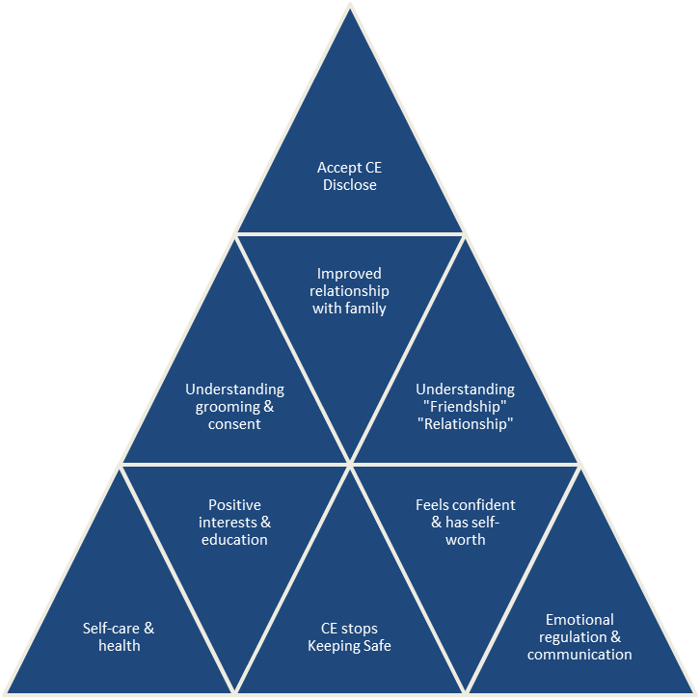

6.4 CE models and push and pull factors
- Recognising the type of CE model and identifying the individual push and pull factors is integral to analysis of CE. Some CE models to consider are:
- Peer on Peer: children being exploited by peers who are known to them.
- Online: abuse of social media to exploit children
- Boyfriend/Girlfriend model: children are befriended directly by the perpetrator (in person or online) or through other children and young people. This process may begin with a girl (or boy) being targeted and befriended by a young boy or girl usually known to her as an equal, ie a classmate, a friend of a sibling, or a neighbour. This introductory child later introduces the child to either one or older men (or women), whom s/he may describe as an older sibling or cousin. The older men or women offer the child attention in the form of gifts, flashy cars, cigarettes, alcohol and drugs.
- The Party Model: Parties are organised by groups of men or women to lure young people. Children are offered drinks, drugs and car rides often for free. They are introduced to an exciting environment and a culture where sexual promiscuity and violence is normalised. Parties are held at various locations and children are persuaded (sometimes financially) to bring their peers along.
- Gangs and Groups: With CSE this can take the form of children being used by gang or group members for sex. With CCE this can take the form of being part of an urban street gang or an organised crime group where children are used to commit offences or transport drugs or weapons.
- County lines is a term used to describe gangs and organised criminal networks involved in exporting illegal drugs into one or more importing areas (within the UK), using dedicated mobile phone lines or other form of “deal line”. They are likely to exploit children and vulnerable adults to move (and store) the drugs and money and they will often use coercion, intimidation, violence (including sexual violence) and weapons. (Home Office 2018)
Push and Pull factors will differ depending upon the individual child’s circumstances. Some common push and pull factors are:
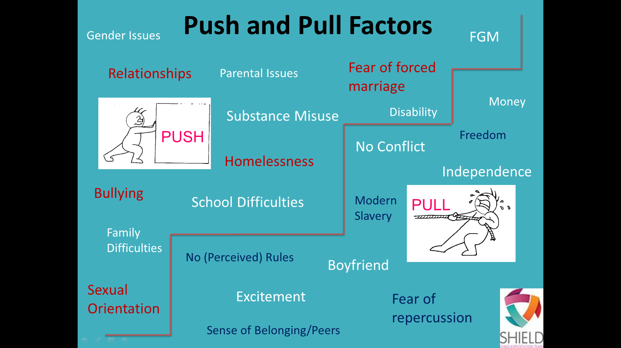
6.5 Shield Interventions and Consultations
Knowsley Shield team consists of the commissioned service Catch 22 and Knowsley council social workers. The Shield Coordinator and MACE will determine what level of Shield resources may be required which may be a referral to Catch 22 or allocation of a Shield social worker.
Shield also offers anyone in Knowsley council a Shield consultation which using the principles of the guidance and research listed above. The consultation will assist in analysing the information within the CE 2 and then offer guidance on sequencing of intervention plans. To book a consultation please email Shield@knowsley.gcsx.gov.uk
Shield will also be responsible for training all CE Champions on a quarterly and if a CE Champion requires any advice or guidance they can contact the Shield Coordinator.

Section 7 Information Sharing Agreement
Knowsley CE policy is in accordance with the Pan Merseyside Information Sharing Agreement which has been signed and rectified by Merseyside Police and five boroughs of Merseyside contained in Appendix 11 in the Pan Merseyside Multi-Agency Child Exploitation Protocol 2018. A copy of this information sharing agreement has copied to Appendix G of Knowsley Policy. A flowchart of key questions for information sharing (see Appendix H)
All Police intelligence on trends, patterns or hotspots will be saved on Shield Sharepoint and Police systems. Any mapping exercises in relation to groups will be saved on Shield secure Egress system.
Section 8 Where an agency has soft intelligence
Where an agency has soft intelligence this should be shared with Crimestoppers, an independent charity who helps to solve crimes. Crimestoppers have an anonymous 24/7 phone number 0800 555 111, that agencies can call to pass on information about crime. Crimestoppers should only be used for intelligence submissions where details of a child are not known. Safeguarding concerns in relation to identifiable children need to be submitted via the process outlined above.
If intelligence is in relation to CSE or CCE then please complete a Shield information/intelligence form (see appendix I) and send to Shield@knowsley.gcsx.gov.uk.
Section 9: Complaints Procedure
If a complaint is made against a specific worker then the agency complaints procedure should be followed. If a complaint is made regarding the Criminal Exploitation process, the Safeguarding Boards complaints procedures should be applied.

Appendix A – MARTHR referral form

Appendix B - Police MACE preparation template

Appendix C - Merseyside Child Exploitation 1 (CE1) referral Form

Appendix D - Things to consider in a strategy meeting

Appendix E- Merseyside Child Exploitation 2 (CE2)

Appendix F - Child’s notification of placement with CSE or CCE concerns
Appendix G - Pan Merseyside Information Sharing Agreement

Appendix H – Flowchart of key questions for information Sharing

Appendix I - Shield intelligence/information form

Appendix A
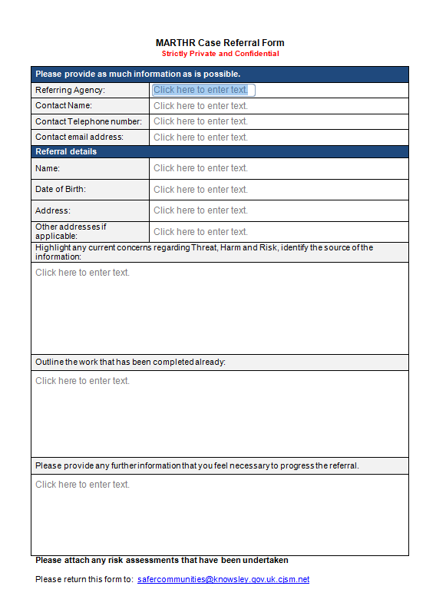

Appendix B
Police MACE preparation template

Any investigations closed in the last 3 months?

Any new investigations in the last 3 months?

Update on any current investigation (including out of borough investigations)

Any information whereby the child is a victim or suspect in the last 3 months?

Appendix C



Merseyside Child Exploitation 1 (CE1) Referral Form

Type of Referral:

Child Criminal Exploitation Child Sexual Exploitation Both

Child Details:
Forename(s)……………………………… Surname ……………………………………… D.O.B.…….…...………….............. Ethnicity………………………….. Gender………………………….….. Disability ….………………………
Address…………………………………………………………………….. Postcode….………………………..

This address is:
Home / Other family member address / Foster care / Children’s Home / Semi-Independent / Hostel / Secure unit / Other (please state) …………………………………
Home Tel No. ……………………..……...Mob / other contact No.…………….…………….…
GP Name..………… ………………………….…………………….............
Surgery Address………………………….…………………….............

School ……..……………………………………
Not in Education, Employment or Training (NEET): Yes/No

Parent/Carer Details:
Forename(s) ………………………….. …Surname ………………………….. ……
Relationship: ………………………….. Contact No. …………………………..………

Referring Person Details:
Name …………………………………………Date of referral……………………………………
Agency Name ……………………………… Job Title……………………………………………
Agency type:
Health / Children’s Services / Education / Youth Services / Police / Probation / Voluntary services
Other – please state……………………………………....
Email address…………………………………………Telephone No.………………
Lead Agency Involvement:
No Lead Agency | Early Help Plan | Child in need | Child Protection Plan | LAC / Leaving Care

Lead practitioner name…………………………………………………………………………………………....
Is this child placed from a different Local Authority? YES /NO
If yes – state which and if known what date have they been placed since?

Suspected Perpetrator Details:
Forename(s)……………………………… Surname ………………………………………
Gender …………………………. Ethnicity….…...………….........
Approximate Age ………………………….
Address if known…… …………….

Which of the following are applicable to this child?

 | Yes | No | Unknown
Regularly missing
Parents / Carers not reporting child missing
Drug or alcohol misuse
Has extra money/new items/‘gifts’ that cannot legitimately be accounted for/received from unknown sources
Change in physical appearance or behaviour
Pregnancy, termination or repeat testing for sexually transmitted infections
Child has been coerced to take/share indecent images
Arrested/Involved in criminality
Found / travelling out of Borough
Multiple mobile phones
Child feels indebted to an individual or group
Family or child having to move or leave their home
Items missing from home
Child carrying / concealing weapons
Associates known to be involved in criminality or Organised Crime Groups (OCG’s)
Absent from school / Non-school attendance
Services have not been able to engage with child
Living in a chaotic / dysfunctional household
Low self-esteem / self confidence
Association with others who have been exploited
Self-harm indicators and/or mental health concerns and/or suicidal thoughts/attempts
Injuries – evidence of physical or sexual assault
Relationship breakdown with family and or peers
Homeless
Child has limited age appropriate friendships
Association with older and/or risky peers
Young Carer
Change in education attendance/Change in education provider/Missing from education/Non-attendance in education
Child’s sexuality increases their vulnerability as they feel unaccepted due to sexual orientation
Are Parents / Carers aware of these concerns?
Does the child have awareness of these concerns?
Does the child consent to you sharing this information?
Does the parent consent to you sharing this information?

Evidence for above tick answers and reason for referral (please give as much information as possible):

Please send this form via Social Care Front Door to the MACE
(Multi Agency Child Exploitation)

It is the responsibility of the referring agency to determine whether the referred child’s parents are informed that their child will be discussed at the MACE meeting.

Best practice would be to inform/consult with parents; however, this may prove detrimental in certain cases. It may not always be in the child’s best interests to inform parents and each case should be considered individually.

Appendix D
Things to consider in a CE strategy meeting
- Immediate presentation of the child when arrested – if not eating and being extremely aggressive in custody – consideration that the child may have secreted drugs internally.
- Who was arrested with the child – any adults and other children from other boroughs? Need to consider further mapping and understanding of their connections.
- Has the parent reported their child missing and if not why not? Is there evidence that parents are fearful of reporting? Is there evidence parents might be involved?
- What is the parent’s capacity to report missing or safeguard now?
- If not reported missing some exploration on how long we think this child has been exploited across county lines?
- Does this require a National Referral Mechanism referral? Who is going to complete the NRM?
- Who is going to complete the CE 1?
- Are there any other associates, names linked to this child that also may be being exploited?
- Are there any injuries?
- How has the child presented?
- History to look at any of the key warning signs of exploitation:
- Absent from school
- Staying out late/overnight
- Regularly missing
- Unexplained gifts/new possessions
- Drugs and alcohol use
- Secretive behaviour
- Offending behaviour
- Inappropriate or sexualised behaviour
- Significant changes in mood or behaviour
- Becoming withdrawn or isolated
- Changes in appearance (clothes, hygiene etc.)
- Mental health changes / self-harm
- Excessive time spent on social media talking to “friends” they haven’t met.
- Pregnancy, terminations or repeat testing for sexually transmitted infections
- Child has been coerced to take/share images
- Being found traveling to an unfamiliar area
- Multiple mobile phones
- Family or child having to leave the home
- Items missing from home
- Child is carrying/concealing weapon
- Association with others who have been exploited
- Injuries
- Family breakdown
- Homeless
- Child has limited age-appropriate friendships

Appendix E: CE 2

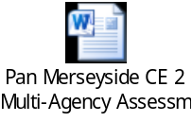

Appendix F- Child’s notification of placement with CSE or CCE concerns


Child’s notification of placement with CSE or CCE concerns
Date of meeting |  |  |  | Name of child
Name of social worker |  |  |  |  | Name of Shield social worker
- Any previous CSE or CCE investigations? |  |  |  | Yes |  |  |  |  |  |  |  | No
- Any ongoing CSE or CCE investigations? |  |  |  | Yes |  |  |  |  |  |  |  | No
If yes – what are the  investigating officers contact details |  |  |  | Name
 |  |  |  | Email
 |  |  |  | Phone
- Has all strategy meeting and safeguarding been addressed in relation to the ongoing investigation/s
- Any documentation in relation to the CSE or CCE concerns?

- What are your local processes in relation to CSE or CCE concerns?

- Knowsley processes have been explained |  |  |  |  |  | Yes |  |  |  |  |  |  |  |  | No
- Has CE 1 or CE 2 been provided for them to complete? What timescales have been agreed for receipt of these documents?

CE1 |  |  | Agreed Time Scale
CE2 |  |  | Agreed Time Scale
- Copy of the care plan or CSE or CCE plan has been provided? If not what timescales have been agreed for receipt of these documents?

Care Plan |  |  | Agreed timescale for receipt
CSE Plan |  |  | Agreed timescale for receipt
CCE Plan |  |  | Agreed timescale for receipt
- Who is completing work on CSE or CCE concerns?

CSE |  |  |  |  |  |  |  |  |  |  | CCE
Name |  |  |  |  |  |  |  |  |  |  | Name
Email |  |  |  |  |  |  |  |  |  |  | Email
Contact number |  |  |  |  |  |  |  |  |  |  | Contact number
- Are there concerns in relation to missing episodes?

- Any areas or associations of concern that we need to be aware of?

Appendix G
PAN MERSEYSIDE INFORMATION SHARING AGREEMENT

Parties acknowledge the imminent change in legislation by the introduction of General Data Protection Regulations (GDPR) and the Data Protection Act on the 25/05/2018 and will work together to update this Information Sharing Agreement to become compliant with the new legislation

INTRODUCTION
The aim of this Agreement is to define the specific purposes for which Merseyside Police and Partners have agreed to share information; namely to increase the safety, health and wellbeing of victims of/or at risk of Child Exploitation (CE), for the prevention and detection of crime and maintenance of community safety. It is envisaged that relevant information will be shared regarding referrals involving both adults and children where vulnerability is identified. Long established methods of sharing information between agencies has been key to identifying thresholds and suitable referral pathways.
1.2 This Agreement sets out the legal provisions relating to personal data sharing and takes account of the relevant Codes of Practice in respect of the sharing of personal data held by the Merseyside Police (MOPI Guidance, the ACPO Data Protection Manual of Guidance and ICO Data Sharing Code of Practice).
1.3 This Agreement contains details of the standards agreed by the Parties involved in the sharing of personal data and personally identifiable information so as to maintain confidentiality, integrity and compliance with the data protection principles, whilst ensuring that information is shared with those who ‘need to know’.
1.4 Requests for information will be considered on a case by case basis in light of this Agreement and the relevant legal parameters identified concerning the sharing of personal data. The MASH enables co-located professionals to make this expedited judgment together and record the decision to share the information, along with the rationale.
1.5 Information shared under this Agreement must not be disclosed to any persons who are not Parties to it (including other business area within the same organisation) without prior consent of the information provider(s), or if there is any risk that the requirements of this Agreement might be breached.
PURPOSE OF THIS AGREEMENT
2.1 The purpose of this Agreement is to establish the procedures for the lawful, secure and effective exchange of information between the parties, in order to enable the parties to share relevant information in a comprehensive, transparent and consensual manner in the interests of safeguarding children and to work towards the maintenance of community safety and the prevention and detection of crime and disorder.
2.2 This section states that the purpose for parties to share information is:
To increase the safety, health and wellbeing of victims of/or at risk of criminal exploitation;
- Better informed decision making and partnership working to identify and manage
- risk of serious harm;
- keeping victims safe, promoting safer communities;
- Prevention and detection of crime and disorder;
- Identify and target offenders;
- Determine if the perpetrator poses a significant risk to any particular individual or to the general community;
- Jointly construct and implement a risk management plan that provides professional support to all those at risk and reduces the risk of harm;
- To identify thresholds and suitable pathways;
- To enable agreement on appropriate intervention.

The Children’s Act 2004 emphasises the importance of safeguarding children by stating that relevant partner agencies must make sure that functions are discharged having regard to the need to safeguard and promote the welfare of children. The Act also states that they must make arrangements to promote co-operation between relevant partner agencies to improve the wellbeing of children in their area. Wellbeing is defined as relating to a child’s:
- Physical and mental health and emotional, wellbeing (be healthy)
- Protection from harm and neglect (stay safe)
- Education, training and recreation (enjoy and achieve)
- The contribution made by them to society (make a positive contribution)
- Social and economic wellbeing (achieve economic wellbeing)

For the purpose of this Information Sharing Agreement the term child means anyone under the age of 18.
Accordingly, relevant partner agencies are also expected to comply with the requirements of Working Together 2015 and the associated Information Sharing guidance for practitioners and managers.
LEGAL CONSIDERATIONS FOR SHARING
3.1 The sharing of information must have due consideration with the law relating to confidentiality, data protection and human rights. Cognisance should be given to whether it is reasonable to gain full consent of the Data Subject.
3.2 When the consent of a Data Subject is refused or it is not reasonable to seek consent, legal powers must be identified on a case by case basis.
3.3 There will be consideration of the implications of Article 8 of the European Convention on Human Rights, which provides an individual right to respect for private and family life, home and correspondence. This is a qualified right and where no consent has been obtained, it will be necessary to ensure that the data sharing is in accordance with the law and necessary in a democratic society in the interests of national security, public safety, prevention of crime and disorder. The information to be exchanged must be proportionate for the needs of this is Agreement.
3.4 The power for Merseyside Police to share information is founded on the common Law for policing purposes. The Code of Practice ono the Management of Police Information (MoPI) defines the policing purposes as:
- Protection of life and property;
- Preserving order;
- Preventing the commissioning of offences;
- Bringing offenders to Justice;
- Any duty or responsibility arising from common or statute law.

3.5 The Data Protection Act 1998 applies if the information is personal data relating to a living individual and held on a computer or as part of a ‘relevant filing system’ in hard copy material (see glossary). To process information, the Data Controller must ensure compliance with the principles of the Data Protection Act. Specific consideration must be given as to whether the information will be processed fairly and lawfully and for the specified purpose for which it is held.
3.6 The joint legal considerations for sharing of information in a MASH.
First Principle
The first data protection principle states that data must be processed lawfully and fairly and in accordance with a condition in schedule 2 for personal data and a condition in both schedules 2 and 3 in respect of sensitive personal data of the Data Protection Act 1998.
A public authority must only share personal data when there is an identified legal power to do so.
If the information to be shared falls into the statutory threshold of section 17 of section 47 of the Children’s Act
1989 then this will provide the legal gateway for the sharing of the information (because of the provisions in section 35 DPA).
Sections 10 and 11 of the Children’s Act 2004 places new obligations upon the Police, Local Authorities and
Primary Care Trusts to cooperate with other relevant partners in promoting the welfare of children and also ensuring that their functions are discharged having regard to the need to safeguard and promote the welfare of children. This piece of legislation gives the statutory power to share information for the purposes of this Agreement.
Although section 29 of the Data Protection Act 1998 does give a power to disclose information, it does not provide a legal obligation to do so. It does state that if not disclosing information would prejudice the prevention/detection of crime and/or the apprehension/prosecution of offenders, personal data can be disclosed. Under this agreement, if not disclosing information to the MASH would prejudice the reasons listed above, organisations are exempt from the usual non-disclosure provisions and may share the information requested. This will be decided on a case by case basis.
The conditions for disclosure that are relevant to this document are in Schedules 2 and 3 of the Data Protection
Act 1998 and include conditions 3 (legal obligation) and 5 (administration of justice) of Schedule 2, as well as condition 4 (vital interests of the data subject). Schedule 3 conditions 6 and 7 are also relevant to the processing of sensitive personal information and its disclosure.
The Data Protection Act permits the sharing of personal information when it is:
In the vital interest of the data subject, or in the public interest.
Duty of Confidence
Data subjects will have a legitimate expectation that the Police will act appropriately with regards to the sharing of their information for the purposes of preventing harm to or promoting the welfare of vulnerable people.
When applying proportionality and necessity to the decision to share this information with partner agencies, the protection of children and/or other vulnerable people would usually fulfil a public interest test as long as that disclosed is relevant and proportionate.
Information held by other agencies that will be shared in the MASH may have been gathered where a duty of confidence is owed. Duty of confidence is not an absolute bar to disclosure, as information can be shared where consent has been provided or where there is a strong enough public interest test to do so, or the law allows such sharing.
Obtaining consent remains a matter of good practice and in circumstances where it is appropriate and possible, explicit consent should be sought and freely given by the data subject.
However, in many cases the aims of the MASH might be prejudiced if agencies were to seek consent. In such cases the disclosing agency must consider possible grounds to override the consent issue. It is possible to disclose personal information without consent if this is in the defined category of public interest.
The public interest criteria include:
- The administration of justice;
- Maintaining public safety;
- The apprehension of offenders;
- The prevention of crime and disorder;
- The detection of crime;
- The protection of vulnerable members of the community.

When judging the public interest, it is necessary to consider the following:
- Is the intended disclosure proportionate to the intended aim?
- What is the vulnerability of those who are at risk?
- What is the impact of disclosure likely to be on the individual?
- Is there another quality effective means of achieving the same aim?
- Is the disclosure necessary to prevent or detect crime and uphold rights and freedoms of the public?
- Is it necessary to disclose the information, to protect other vulnerable people?

The rule of proportionality should be applied to ensure that a fair balance is achieved between the public interest and the rights of the data subject.
All disclosures must be relevant and proportionate to the intended aim of the disclosure.
Fair Processing
It is a requirement of the Data Protection Act 1998 that all organisations that process personal data should have a fair processing notice, which will inform individuals about how their personal data will be used by that organisation. This notice will cover;

- The identity of the data controller.
- The identity of the representative.
- If the data controller has nominated a representative for the purposes of the Act - the identity of that representative.

The purpose or purposes for which the data are intended to be processed. Any further information which is necessary, taking into account the specific circumstances in which the data are or, are to be processed, to enable processing in respect of the data subject to be fair.
A notice explaining the concept of MASH and how it works in Merseyside will be made available on relevant agency websites.
Section 29 of the Data Protection Act 1998 allows agencies to share information if, complying with the fair processing conditions, would be likely to prejudice the purposes of the prevention of detection of crime and/or the apprehension and prosecution of offenders. If staff or signatory agencies receive information which they believe that, by not disclosing the information, the Police will be unable to prevent or detect crime or the Police will be unable to apprehend or prosecute an offender, then they may fairly share that information with the Police.

Legitimate Expectation
The sharing of relevant information by the Police fulfils a policing purpose, in that it will be done in order to protect life in some circumstances and in other it will fulfil a duty upon the Police provided by statute law (Children’s Act 2004) i.e. cooperation to improve the well-being of children.
It can reasonable be assumed that the persons from whom information is obtained will legitimately expect that the Police will share it appropriately with any person or agency that will assist in fulfilling the policing purposes mentioned above.
In cases where legitimate consent can be obtained this will be done. Individuals will have a legitimate expectation of how their data is going to be used and with whom it will be shared and why.
The Information Sharing Agreement will be published as part of a Public Authorities Publication Scheme, in line with the Freedom of Information Act 2000, which provides opportunity for members of the public to understand how personal information may be used within the MASH.
Human Rights Act – Article 8: The Right to Respect for Private and Family Life, Home and Correspondence.
There shall be no interference by a public authority with the exercise of this right except such as in accordance with the law and is necessary in a democratic society in the interests of national security, public safety or the economic wellbeing of the country, for the prevention of disorder or crime, for the protection of health or morals, or for the protection of the rights and freedoms of others.
The sharing of information with Children’s Services may be in contravention of Article 8, however the benefits of effective sharing of information for the purposes of this Agreement are to the direct benefit of the citizen and, therefore, are in the public interest. This Agreement is:
In pursuit of a legitimate aim
The promotion of the welfare and wellbeing of children and ensuring that they achieve all five outcomes is, by virtue of Section 11 of the Children Act 2004, a legitimate aim and is the major responsibility of the signatories to this Agreement. The Sharing of Information under this Agreement is also in line with Articles 2 and 3 of the Human Rights Act 1988, namely the Right to Life and the Right to Prohibition of Torture or Inhumane or Degrading Treatment.
Proportionate
The amount and type of information shared will only be the minimum necessary to achieve the aim of this Agreement. Information is always to be considered in terms of its proportionality in each set of circumstances, but it must always be remembered that the right to life is paramount. An activity appropriate and necessary in a democratic society.
The Police are obliged to do all that is reasonable to ensure the welfare of the most vulnerable people and this is something that is necessary and appropriate in a democratic society. Other signatories to this Agreement, such as Health and Children’s Services also have similar obligations, which are necessary and appropriate in a democratic society.
Schedule 2, Data Protection Act 1998
In addition to the legal criteria set out above, the Information Sharing Agreement must satisfy at In addition to the legal criteria set out above, the Information Sharing Agreement must satisfy at least one condition in Schedule 2 of the Data Protection Act in relation to personal data.
Schedule 2 is satisfied in the case of this Agreement by Condition 5 (b) (The exercise of functions conferred under the statute) as there is an implied gateway available for the Sharing of Information in these circumstances under Section 11 Children Act 2004, which obliges the relevant agencies to ensure that their functions are discharged having regard to the need to safeguard and promote the welfare of children.
Where the consent of the individual is received, Condition 1 (data subject has given consent to the processing of their data) will apply.
Schedule 3, Data Protection Act 1998
If the information is sensitive (that is where it relates to race, ethnic origin, political opinions, religion or belief system, membership of a Trade Union, physical/mental health or sexual life, the commission or alleged commission of any offence, proceedings related to the offence) you must satisfy at least one condition is
Schedule 3.
Schedule 3 is satisfied in the case of this Agreement by Condition 7; the processing is necessary for the exercise of any functions conferred on any person by, or under, an enactment (i.e. Children’s Act 2004).
Where the consent of the individual is received, Condition 1 (data subject has given explicit consent to the processing of their data) will apply.
3.7 For the purpose of this Agreement, the parties will be Data Controllers in their own right, as defined under the Data Protection Act 1998 and will be required to comply with the provisions of the Act. Accordingly, it is the responsibility of each party to ensure that they have appropriate agreements in place with regard to the processing of information that is personal data on their behalf.
3.8 In addition, under the Data Protection Act, Data Subjects have a right of access to records that are held about them. Further details are set out at Section 8.
3.9 The parties will take account of the Common Law Duty of Confidence in respect of identifiable information.
3.10 The Common Law Duty of Confidentiality requires, that unless there is a statutory provision to use information that has been provided in confidence, it should only be used for that purpose(s) for which the subject has been informed and has consented.
3.11 The Common Law duty is not absolute and can be over ruled I the disclosure is in the public interest (e.g. to protect others from harm). The information to be shared within the context of this Agreement will contain information that has been received in confidence by any of the parties to this Agreement.Most information given to the Police will carry with it a legitimate expectation by the provider of the information that it will be used in the detection or prevention of crime or for other legitimate policing purposes. Therefore, the decision whether or not to share information will be on a case by case basis. The MASH will enable co-located professionals to make this expedited judgment and record the decision to share along with the rationale.
3.12 Caldicott Guardian
As a result of the 1997 report of the review of Patient Identifiable Information chaired by Dame Fiona Caldicott (the Caldicott report), each NHS organisation has appointed a guardian of person based clinical information to oversee the arrangements for the use and sharing of clinical information. Subsequently, the requirement to appoint Caldicott guardians was extended into Councils with social care responsibilities.
A key recommendation of the Caldicott committee was that every use or flow of patient identifiable information should be regularly justified and routinely tested against the principles developed in the Caldicott Report.
Principle 1 – Justify the purpose for using confidential information.
Principle 2 – Only use it when absolutely necessary.
Principle 3 – Use the minimum that is required.
Principle 4 – Access should be on a strict ‘need to know’ basis.
Principle 5 – Everyone must understand his or her responsibilities.
Principle 6 – Understand and comply with the law.

The MASH will operate within Caldicott guidelines.
RESTRICTIONS ON USE OF INFORMATION
4.1 Information must be treated as private and confidential and will not be divulged or communicated to any third parties (including other business areas within the same organisation) without prior consent of the information provider, provided this shall not restrict usage that is necessary for the purposes set out in Paragraph 3.4. Decisions about who needs to know and what needs to be known will be made on a case by case basis and should, in every case, be within the constraints of the legal framework shown in Paragraph 3.6. Decisions made in respect of Child Exploitation (CE) cases, actions and associated rationale should be recorded on the CE2.
Staff co-located within the MASH should ensure that spontaneous decisions made within the confines of the hub are documented adequately so as to satisfy the regulations herein and in a manner that enable them to be created, stored, managed, audited and destroyed accordingly.
4.2 Information will not be matched with any other personal data otherwise obtained from the disclosing party or any other sources, apart from the purpose specified on the Request for Personal Data made to parties to this Agreement, unless specifically authorised in writing by the disclosing party.
4.3 Access to the information will be restricted to authorised employees of partner agencies to this Agreement as approved by Merseyside Police. Each participating agency is responsible for ensuring that reasonable efforts have been made to establish the trustworthiness and integrity of the individuals who process personal and other sensitive information covered by the terms of this protocol. These individuals must be aware of the requirement for them to process personal and other sensitive information securely, in compliance with the relative legislation and, only for the purposes prescribed by this document.
WORKING PROCEDURES
5.1 All personal data remains the property of the disclosing agency and is the responsibility of the Data Controller. Each of the participating agencies will have a Data Controller. This will be a senior officer who will ensure that received data is processed only for the purposes for which it was received. Each partner must appoint a Single Point of Contact (SPOC). The SPOC will be responsible for administering this Agreement. If the SPOC is unavailable then the duties can be delegated to a suitably trained person. In order that information flows expeditiously and remains under control, parties co-located within a MASH will be more readily able to manage the process.
5.2 All parties may, by agreement in writing, change their identified SPOC(s).
5.3 Employees of the parties will be responsible for processing information in compliance with this Agreement.
5.4 The named employees of partner agencies will ensure that any requests for information are made in writing using an agreed format.
5.5 All parties will maintain an auditable a record of all information sharing.
5.6 Signatories the Agreement must review and weed data as per Paragraph 8.3
5.7 In certain circumstances, it may be necessary to seek information urgently and, in such cases, the information may be sought and disclosed verbally. Where this is the case, each party must keep a record of the request and the response by the completion (in retrospect) of the usual forms.
5.8 The data disclosed must be treated as private and confidential and will not be divulged or communicated to any third parties (including other business areas within the same organisation) without prior consent of the information provider.
5.9 Any issues arising in respect of the procedures referred to within this Agreement should be referred to the relevant signatories.
DATA
6.1 Examples of data that may be shared include:
- Name of subject and other family members, their carers and other persons whose presence and/or relationship with the subject is relevant to identifying and assessing the risk to that person;
- Age/date of birth of the subject and other family members, carers or other significant person;
- Ethnic origin of the subject and other family members, carers or other significant person;
- Relevant Police information and intelligence;
- Relevant school and educational information of the subject and other family members, carers or other significant person;
- GP and health records (to include family members where appropriate and relevant);
- Relevant ASB data;
- Relevant data from North West Ambulance Service and Merseyside Fire and
- Rescue Service, where appropriate;
- Relevant housing and other partnership data relevant to the subject;
- Relevant information about offenders known to the Probation/YOS services;
- MARAC information, where appropriate;
- MACE meeting information and referrals.

Not all of the above information will be shared in every case. Only relevant information will be shared on a case by case basis where an organisation has a need to know about the information.
6.2 The parties agree to apply appropriate security measures in accordance with Principle 7 of the Data Protection
Act 1998, which states that “appropriate technical and organisation measures shall be taken against unauthorised or unlawful processing of personal data and against accidental loss or destruction or damage to personal data”.
6.3 If any party to this Agreement becomes aware of a security breach or breach of confidence in relation to the data covered by this Agreement or breach of Terms of the Agreement, the party with responsibility for the area of activity in which the breach occurred shall:
- Report the breach immediately to Merseyside Police Information Governance Manager;
- Report it to the relevant parties immediately;
- Immediately investigate the cause, effect and extent of the breach;
- Report the results of the investigation to the other parties without delay;
- Use all reasonable efforts to rectify the cause of such breach.

Any disclosure of information by an employee which is deemed to have been undertaken for illegal or otherwise unscrupulous purposes (for instance, actions undertaken in bad faith or for motives of personal gain) will be subject of an investigation and be treated as a serious matter.
Each party will be accountable for any misuse of the information supplied to it and the consequences of such misuse by its employees, servants or agents.
6.4 In order to protect the integrity and confidentiality of the information that is held, it is the responsibility of all agencies that are signatories to this Information Sharing Agreement to ensure that there are adequate security arrangements in place.
6.5 Agencies who are signatories to this Information Sharing Agreement, agree that:
Each agency is responsible for the safe and confidential storage of case information;
Access to agency computer databases is restricted to authorised personnel only;
When leaving computers for short periods, users must activate secure screen locks or log off from the password protected application or account that contains personal or sensitive information. When leaving computers for longer periods or when leaving the premises, users must close down their computer accounts
Access to the information must be restricted to users who have the authority to see such information and for the agreed purpose.
6.6 Confidential information or intelligence that is deemed necessary to share with partner agencies must be handled by management level in the partner agencies.
6.7 The parties are required to handle all data received in accordance with the protective marking shown. If no marking is shown the data should be handled in accordance with at least RESTRICTED GPMS marking. This includes ensuring that all data exchanged as a function of this Agreement is stored securely, is only accessible to authorised persons, is not altered, lost or destroyed, is retrieved and transmitted only by property authorised persons and that the information remains accessible by the organisation for business continuity purposes.
6.8 Where data is shared by e-mail the parties agree to set up a secure e-mail account within the Criminal Justice Extranet. Recognised secure sites:
pnn.polic.uk
gsi.gov.uk
gcsx.gov.uk
gss.net.uk
cjsm.net
nhs.net
6.9 Merseyside Police reserve the right to conduct a Site Security Assessment to establish that an appropriate level of security is provided by the partner agency at a time and date convenient to both parties prior to the commencement of the sharing. If recommendations are made by Merseyside Police these should be implemented by the partner agency prior to the commencement of the sharing.
6.10 During the term of this Agreement, the Chief Constable reserves the right to undertake a review of security provided by any party and may request reasonable access during normal working hours to the other party’s premises for this purpose. Failure to provide sufficient guarantees in respect of adequate security measures will result in the termination of this Agreement. Relevant personnel as delegated by Merseyside Police shall undertake these checks.
6.11 The Chief Constable may wish to undertake reliability and suitability checks on any persons having access to the Data and further reserves the right to issue instructions that particular individuals shall not be able to participate in the processing of the Data without reasons being given for this decision. Upon request, all persons having access to personal data as part of this Agreement will be required to give consent to background enquiries in accordance with Merseyside Police Vetting Policy.
6.12 The partner agency agrees to comply with all reasonable requirements concerning the storage, access or use of any Data as may from time to time be made by the Information Governance Manager
6.13 Upon request the Partner Agency will provide the Information Governance Manager with a copy of its documentation describing its security policies and procedures and working practices prior to commencement of this Agreement. Where the standards set out in this Agreement differ from those set out in the documentation those affording greater security should be adhered to.
6.14 The partner agency undertakes not to use the services of any sub-contractors in connection with the processing of the Data without the prior written approval of the Information Governance Manager. Furthermore any access to the premises used to process the Data by maintenance or repair contractors, cleaners or other non-authorised persons must be closely supervised to ensure that there is no access to the Data.
6.15 Any information security breaches, including threats, weaknesses, and incidents of unlawful processing, accidental loss, destruction or damage to data where Merseyside Police is identified as being the data owner or a relevant partner must be reported immediately to the Anti-Corruption Unit using the Information Security
Breach report.
6.16 The partners recognise that additional powers to serve assessment notices on public authorities have been granted to the information Commissioner. These powers allow access to premises, records and staff etc. to inspect security and compliance with the Data Protection principles. New powers also allow the Information Commissioner to levy fines up to £500,000 for any breaches.
6.17 If there are any doubts about the security of the information being shared the force Information Governance Manager must be consulted.
INDIVIDUAL RIGHTS TO ACCESS INFORMATION EXCHANGED
7.1 The receipt from a Data Subject of a request to access information that includes information provided by
Merseyside Police must be reported to the Merseyside Police Disclosure Manager (Information Bureau) within five working days and in any event prior to any response to the applicant.
7.2 Any request for information under the provisions of the Freedom of Information Act 2000 (FOI) or the
Environmental Information Regulations 2004 (EIR) should be referred to the Merseyside Police FOI Team
(Information Bureau) by way of consultation as soon as any signatory to the Agreement becomes aware that the scope of the request includes a request for information provided by Merseyside Police. However, the recipient of the request remains responsible for the FOI response to be provided, unless the FOI request is formally transferred.
REVIEW, RETENTION AND DISPOSAL
8.1 This Agreement will be reviewed initially after six months from signing and annually thereafter to ensure that it is valid, relevant and up to date.
8.2 Any proposed amendments to the Agreement must be notified to the Merseyside signatory and must be agreed in writing by the parties. All amendments and revised Agreements must be forward to the information Governance Manager, Merseyside Police.
8.3 Information must not be retained for longer than is necessary for the purpose for which it has been disclosed. Records of information shared will be retained for an initial period of six years (as recommended by MOPI). They must then be reviewed to establish any continuing necessity to retain them.
8.4 Information will be disposed of securely in line with each party’s respective record management procedures. If electronic information is to be deleted, specific software must be employed to ensure its total erasure.
AUDIT
9.1 The parties will maintain a complete record of all the data requested by and supplied to other parties. This must include;
- Information shared and for what purpose;
- who it was shared with;
- when it was shared;
- justification for sharing;
- reasoning/rationale for not sharing.

9.2 In order to assess compliance with the Data Protection Act 1988, parties acknowledge that Merseyside Police reserves the right to audit all processing of the data supplied by them under the terms of this Agreement. Upon reasonable notice in writing, the parties agree to allow access to their premises for this purpose.
9.3 The requirement for such an audit will be determined by an assessment of the particular risks to Merseyside Police posed by the processing of data under this Agreement.
COMPLAINTS
10.1 Parties
- Respond to the Information Notices served by the Information Commissioner.
- Investigate any breach of the Agreement.

10.2 If a complaint is received by a third party relating to use of information that is personal data and the complaint is the Data Subject and it relates to a breach of the Agreement, the complaint should be referred to the signatory of the party whose action is the subject of the complaint and that signatory will take appropriate action.
TERMINATION OF THE AGREEMENT
11.1 Any party may at any time, in writing, terminate this Agreement if any party is in material breach of any obligation under this Agreement or if either party believes that after reviewing the operation of the Agreement it should be ended or replaced by a new Agreement.
11.2 If an Agreement is terminated in respect of a material breach of it then the terminating party will provide a written notice of one week. Otherwise, one calendar months’ notice of termination will be required. During the period of such notice, information sharing will not take place with the withdrawing party.
11.3 The obligations of or confidentiality imposed on the parties by this Agreement shall continue in full force and effect after termination of this Agreement.
INDEMNITY AND SIGNATURES
12.1 Each agency will keep the other agencies indemnified against any and all costs, expenses, claims and liabilities arising out of any breach of this Agreement and, in particular, but without limitation, the unauthorised or unlawful access, loss, theft, use, destruction or disclosure by the offending agency or its employees, agents or any other person with control of the offending agency of any data obtained in connection with this Agreement

Appendix H
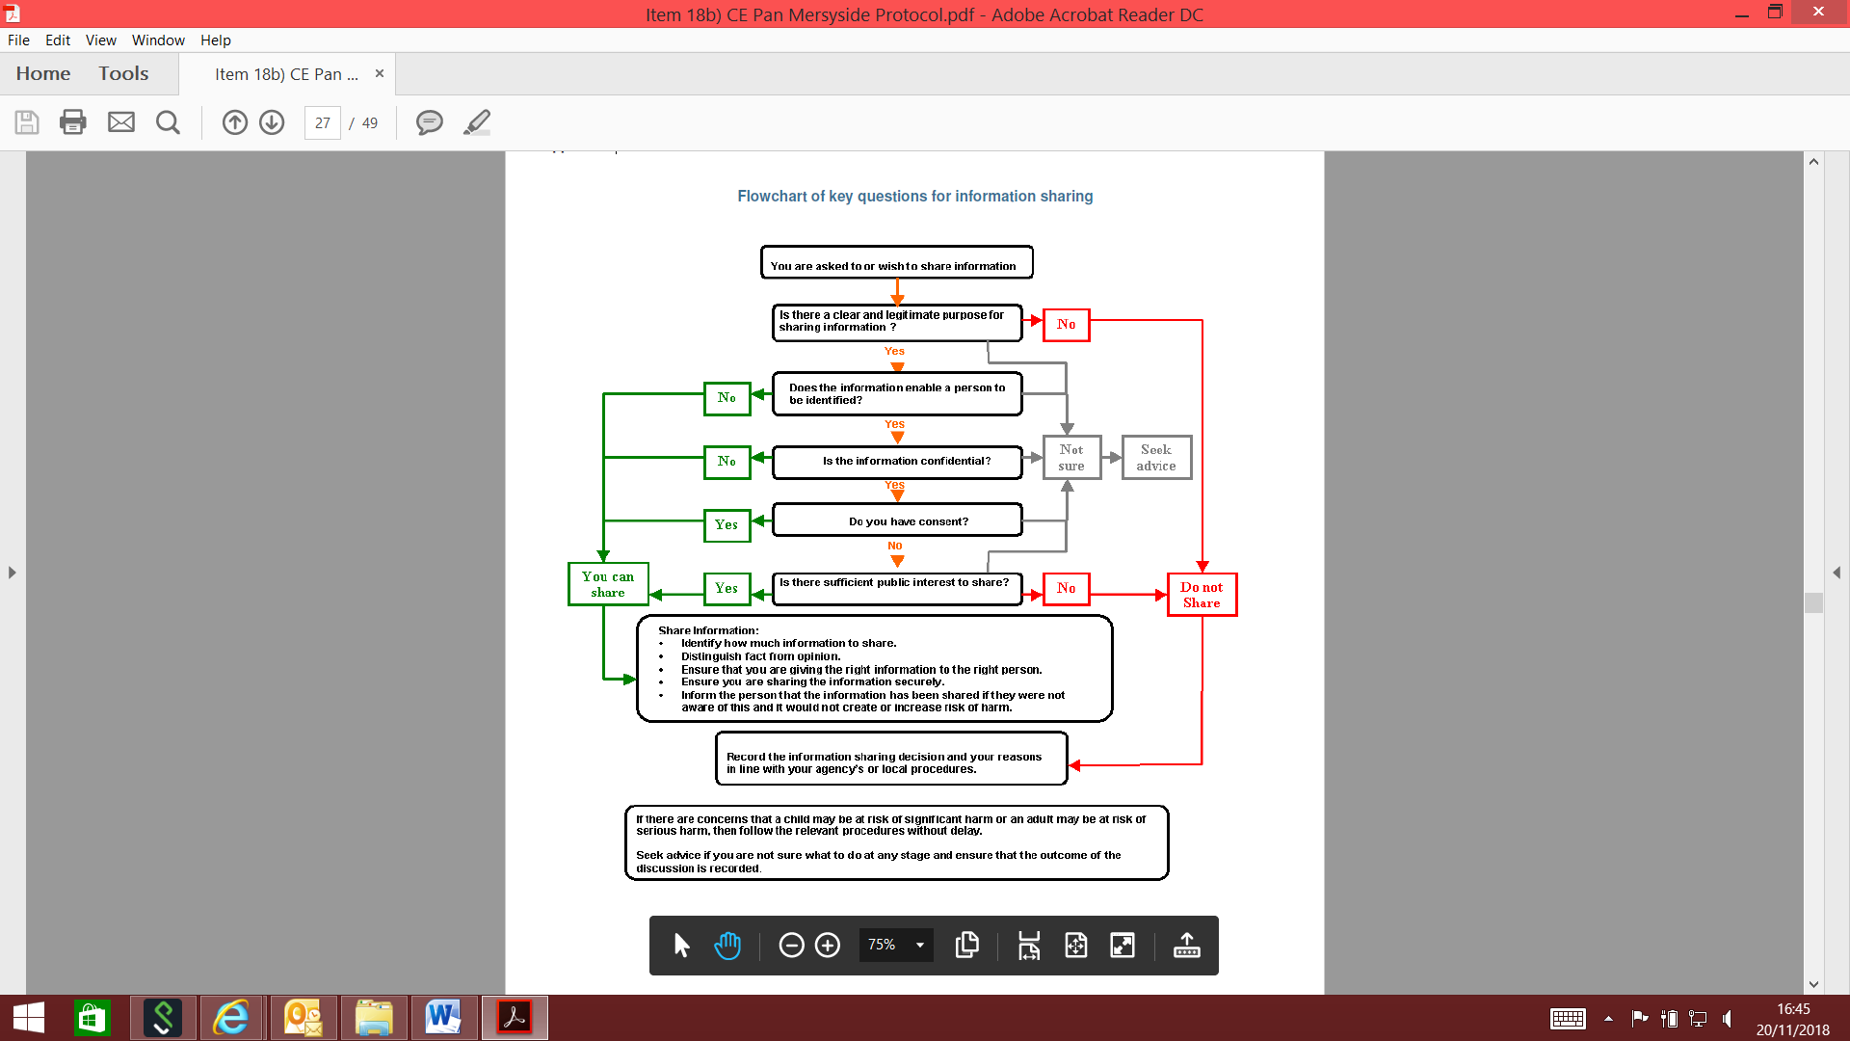
Appendix I

Information / Intelligence Form
Information
Please provide as much detail as possible including names, nicknames, dates of birth (if dates of birth not known approximate age), addresses, places frequented, phone numbers etc.

Who provided this information to you?
Even if the person providing this information / intelligence states they wish to remain anonymous, please still provide details. These details will not be disclosed outside of the CSE Team and will enable us to build up a stronger case to put before any magistrate should the investigation progress this way. Please state whether the person would be willing to be contacted by the CSE Team if necessary.

HOW DO THEY KNOW THIS INFORMATION?

Any reason to suspect this information has been provided maliciously?

Please email to: Shield@knowsley.gcsx.gov.uk

