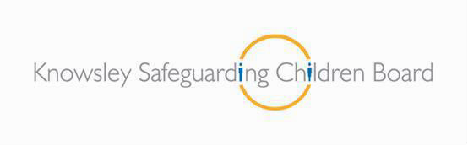

Children who display Inappropriate and Harmful Sexual Behaviour: Procedural Guidance

July 2019

1 | P a g e

Contents

Introduction | 3
Links to Knowsley’s Threshold of Need Guidance (2016) | 3
Recognition | 5
Impact on parents/carers | 6
Consultation | 6
Disclosure & Flowchart | 7
Referral | 8
Strategy Discussion/Meetings | 8 - 9
Possible outcomes from the discussion/meeting | 10
Section 47 enquiries | 10 - 11
Outcome of Section 47 Enquiries | 11
Child/ren in need | 12
Criminal justice processes | 12 - 13
Sexual Harmful Panel (level four) | 13
Safety planning | 14
Home Safety Plans | 14
Risk Management in Schools and the Wider Community | 15
Coordination of education response | 15 - 16
School safety plan | 16
Staffing | 16
Environment | 17
Timetable | 17
Pupils | 17
Community Safety Plan  Transition  Child Looked After – Consent and Confidentiality in Placement Moving out of the Borough  Complaints Procedure References  Contacts | 18  18  18  19  19-20  19  20
Appendices:
Appendix 1: Behaviour The Brook Traffic Light Tool | 21
Appendix 2: A checklist for understanding young people with learning difficulties | 25
Appendix 3: Multi-agency referral form (MARF) | 28
Appendix 4: Risk management planning for LAC children | 28
Appendix 5: Risk Management for Schools and Education | 36-41
Appendix 6: Home Safety | 42-49
Appendix 7: Community safety | 50-52

2 | P a g e

Introduction
The primary objective of all work with children who display inappropriate and harmful sexual behaviour must be the protection of the victim and the prevention of a reoccurrence of the inappropriate and harmful sexual behaviour. It is therefore essential for there to be a coordinated, multi-disciplinary response in accordance with statutory guidance. Helpful national NICE guidance in relation to inappropriate harmful sexual behaviour can be found at https://www.nice.org.uk/guidance/ng55

These procedures are designed to provide guidance for all professionals within Knowsley in how to respond when there is a concern in relation to children who are presenting with inappropriate and harmful sexual behaviour. The procedure offers detailed guidance for professionals when differentiating between normal, inappropriate and harmful sexual behaviour across the age ranges covered by these procedures (0-18 years). Some responses at a low level for example will be for a single agency to respond and others where there is more risk identified will need to be multi-agency and co ordinated as such. This procedure needs to be read in relation to Sexually Active Young People under the age of 18 in Knowsley http://knowsleyscb.proceduresonline.com/chapters/p_wrk_sex_act_yp.html

Workers have to consider the origins of the harmful sexual behaviour and to entertain the possibility that the child may remain at risk of actual or likely significant harm in their own right, indicating the need for dual procedures for them as victims as well as young people who display inappropriate and harmful sexual behaviour. It is widely accepted that children and young people who behave in this way are likely to have considerable levels of unmet needs themselves. Workers need to ensure that whilst children should be held accountable for their inappropriate and harmful behaviour they should also be identified and responded to in a way which meets their needs as well as protecting others. It should also be remembered that children may also pose a risk to others, as well as the victim.

This document outlines the procedures that should be followed by all agencies involved at different stages of the process from time of notification of a sexually inappropriate or harmful incident to completion of relevant stages of intervention. The procedure refers to the following range of children:

- Where inappropriate and harmful sexual behaviour has been identified as a cause for concern
- Where incidents of inappropriate and harmful sexual behaviour have been reported to the police
- Where children have admitted inappropriate and harmful sexual behaviour
- Where young people have been convicted of sexual offending
- Where there is an identifiable victim of sexual behaviour.

Appendix 1 sets out a flowchart for pathways to respond to concerns about inappropriate or harmful sexual behaviour. This ensures suitable responses to sexual behaviour proportionate to the nature of the behaviour.

Links to Knowsley’s Threshold of Need Guidance (2016)

Knowsley’s overarching threshold guidance is designed to help identify when a threshold - or trigger - has been reached, indicating when a child or family might need support and then to identify where best to get this support from. There are four different levels of need with appropriate service responses:

- Level 1 - All children accessing mainstream services with low-level need that can be met by a single agency.

- Level 2 - Children with emerging needs or low level concerns that can be met with the support of a multi-agency Early Help Assessment and Plan.

- Level 3 - Children with multiple or complex needs have to be met by targeted services or by a multi- agency Early Help Assessment or by other specialist assessments e.g. Education Health Care Plan.

- Level 4 - Children who present with acute needs / risk. This includes those at risk of abuse or neglect. They will require a response by Children’s Social Care

Early Help support can be crucial in preventing escalation of concerning behaviour and can involve single or multi-agency delivery and co-ordination of support to the child and their family, to holistically address the range of issues giving rise to the child’s additional needs.

It is essential that partner agencies such as schools, early years settings and health services are willing to adopt the role of Lead Professional and use Team Around the Family (TAF) approach to address any emerging worries regarding sexualised behaviour using a range of appropriate resources and guidance such as those available from the NSPCC for example:

https://www.nspcc.org.uk/preventing-abuse/keeping-children-safe/healthy-sexual-behaviour-children- young-people/

In identifying sexualised behaviour at this stage it is important for professionals not to over-react and to understand that sexual development is a normal part of child development.

Where behaviours appear not to be part of normal development, however, it is important that partner agencies engage with parents and use the TAF process to gather and share information which will identify and address the possible risk factors and associated needs which may put the child at risk of developing patterns of behaviour which may be harmful to themselves and others.

Knowsley Early Help Team can support partners in developing their approach to Team Around the Family and Early Help Assessment and can be contacted on 0151 443 4707.

There is specific guidance that has been adopted in Knowsley to provide a framework in relation to concerns about the sexual behaviours of children for professionals and training through the LSCB is available based on this. The specific guidance to determining healthy to harmful behaviours within developmental age ranges is the Brook Sexual Behaviours Traffic Light Tool (www.brook.org.uk) (See Appendix 2). This tool offers an innovative resource to help professionals who work with children and young people to identify and respond appropriately to sexual behaviour although it is not necessarily sophisticated enough to accurately inform an assessment or response in all cases. It is important also to provide workers with a similar framework for young people presenting with learning difficulties as this can enhance professional anxieties and fuel over- intervention as a consequence. Appendix 3 provides a supplementary framework to guide workers.

‘Sexting’ is an example of behaviour which is inappropriate and criminal but not always immediately harmful and in recognition both police and schools can exercise latitude in their responses while always being mindful to take the appropriate action should a child be deemed at risk of significant harm. The link below is to guidance produced by the DfE for schools and colleges on ‘Sexting’ (Youth Produced Sexual Imagery) and

describes which types of behaviour might be dealt with through formal legal and statutory processes or alternatively through the offer of Early Help and support to those affected.

Professionals also need to be aware of Technology – Assisted Harmful Sexual Behaviour (TA-HSB). TA-HSB refers to one or more children engaging in sexual discussions or acts – using the internet and/or and image-creating/sharing or communication device – which is considered inappropriate and/or harmful given their age or stage of development.

Pornography use may be considered TA-HSB if it is likely to be damaging for the child/young person given their age and/or developmental, emotional and social needs, and/or if it depicts acts which are considered unacceptable according to the British Board of File Classification’s (BBFC) classification of pornographic material.

There also needs to be an understanding that children and young people engage in a range of technology-assisted harmful sexual behaviours. Practitioners need to be able to assess where this behaviour would place a child in terms of the Knowsley model of CIN (child in need).

https://www.gov.uk/government/uploads/system/uploads/attachment_data/file/609874/6_2939_SP_NCA_S exting_In_Schools_FINAL_Update_Jan17.pdf

Recognition
Identifying signs and symptoms of sexual abuse is quite routine and should be considered as everybody’s business. Some of the important factors to take into account when looking at inappropriate and harmful sexual behaviour include:

- The immediate protection of all of the children involved and any others in contact with the child who are alleged to have displayed inappropriate or harmful sexual behaviour.
- The attitude and response of parents or carers and their ability to protect their own child/ren. Can they ensure appropriate supervision is in place around other children?
- The Behaviour:
  - Did both parties agree to the sexual activity? Is the sexual activity age appropriate?
  - How frequently has the behaviour occurred? Has the type of behaviour changed over time?
  - Is there evidence of aggression, force, coercion or bribery?
  - Have the individuals tried to ensure that the behaviour remains secret?
- The child or young person who has displayed harmful sexual behaviour:
  - Have there been any previous concerns around harmful sexual behaviour or lack of sexual boundaries?
  - Whether the child who is alleged to have sexually harmed acknowledges their behaviour or actions, minimises or denies the allegations made.
  - The likelihood or progress of any criminal prosecution.
  - Whether there is any evidence or grounds to believe that the child who is suspected or alleged to have sexually harmed, has also been the victim of abuse themselves.
- The Victim:
  - The age and vulnerability of the victim?
  - The impact on the victim – of both the alleged sexual abuse alongside their response to professional responses
  - The victim’s needs (considered separately from the child who has demonstrated the inappropriate or harmful behaviour)

Impact on parents/carers

Identification or disclosure of inappropriate or harmful sexual behaviour by a child can be extremely distressing not only for the children involved, but also for parents, carers and other family members. They may react with disbelief and minimise the situation which could escalate concerns and it is therefore important that professionals help them through this process at an early stage so that they can support and where appropriate, protect their child. There may also be attempts to hide the abuse by family or peers, including withholding of information or deception, known as “disguised compliance”, from both the child whose sexual behaviour is raising concerns and the victim (who may be under threat or too shamed to disclose). Disguised compliance happens when parents or carers do not own the concern of the practitioner, or don’t admit their lack of commitment to the process and work subversively to undermine it. The practitioner should maintain a focus upon the needs of the child, whilst being sensitive to the impact upon the family. Children or family members can accuse practitioners or become hostile, and this should not stop work with these families to uncover the reality of the child’s life.

Consultation

Where there are concerns about a child displaying inappropriate or harmful sexual behaviour, staff should seek advice, support and consultation to assist their judgement regarding the level of intervention required – ideally with their line manager or safeguarding lead within their agency. Staff should seek information to try and make sense of the behaviour of concern and it is only when information from a number of sources has been shared and assembled that it becomes clear about the level of concern and proportionate response needed.

Where there is suspicion or an allegation of a child having been harmed in a sexual way by another child, it should be referred immediately to the multi-agency MASH team in the local authority where the child lives, using the MARF (Multi Agency Referral Form) (see appendix 4). Both the victim and the child who has allegedly displayed the inappropriate or harmful sexual behaviour will need to be referred for assessment.
If a child is under the age of 13 years old, they cannot legally consent to any form of sexual activity (Sexual Offences Act 2003). Therefore, a child protection referral is required in all such cases.

Action in relation to 13, 14 and 15 year olds

The Sexual Offences Act 2003 reinforces that, whilst mutually agreed, non- exploitative sexual activity between children does take place and that often no harm comes from it, the age of consent should still remain at 16. This acknowledges that this group of children is still vulnerable, even when they do not view themselves as such.

An assessment should take place of the child’s competency to give consent and of the nature of the relationship. Consider any differences of age, maturity, level of development, functioning experience and also the awareness of the potential consequences of their actions.

Whilst not all cases involving sexual activity with a child under the age of 16 years will lead to child protection activity, a conversation with the police should be considered as technically it may constitute a criminal offence and an assessment (including whether the children are Gillick competent using Fraser guidelines) must be undertaken.

7 | P a
Single Assessment and Child
Protection Conference
YES
NO

Single Assessment - CIN

Disclosure

Staff should follow the procedural guidance in relation to appropriate professional responses to disclosures and where any doubt or need for advice exists they should contact MASH, the Police or their designated safeguarding lead.

Pathways of response to sexual behaviour open to Children’s Social Care
Harmful
YES
Is the Behaviour?
NO NO

YES YES
NO
YES
Single Assessment and
Child Protection Conference
NO
YES
NO
g e
Level 3
Is the child at risk of significant harm and/or under age 10?
Level 3
Sexual Harmful Panel
Single Assessment and is the behaviour requiring further specialist sexual assessment

Inappropriate
Healthy
Is the child at risk of significant harm and/or under age 10?
Strategy Discussion
Universal Services
Strategy Discussion

Referral

When an allegation of sexual assault or offence has been made, the police are generally the first point of contact and it is critical for them to always consult with MASH regarding cases that come to their attention and ensure that a VPRF form is shared in order to ensure that there is an appropriate assessment of the victims needs and of the child whose behaviour is allegedly harmful, including any risk factors within and outside the family home. Where a child displays inappropriate or harmful sexual behaviour, but where there is no actual complaint or specific incident, then this information should be shared with Children’s Social Care via the MASH to consider whether any further information available assists in deciding on an appropriate response. If either the victim or the child who has allegedly displayed inappropriate or harmful sexual behaviour is an out of borough child, then Knowsley Social Care will inform the relevant local authority on the same day.

A child under 10 years of age alleged to have displayed sexual inappropriate or harmful behaviour cannot be investigated by the police as they are under the age of criminal responsibility. This means that the responsibility for the investigation lies with Children’s Social Care for inappropriate and harmful sexual behaviour.

Neither child welfare or criminal justice agencies should embark on a course of action that has implications for the other without appropriate consultation.

Concerns should usually be shared with the parent or carer of the child. However, where there is cause for concern of sexual abuse within the family, guidance from statutory services should be sought first, before informing carers or family members. Consideration must be given to prevent any contamination of evidence or revictimisation.

It is important for workers to carefully consider whether the information provided is indicative of inappropriate or harmful sexual behaviour, not least because of the impact of labelling on the child if it is incorrect. The following factors should be considered:

- The age relationship between the children
- Any differences in their size, power, ability or authority
- Whether the behaviour is age inappropriate
- The purpose of the behaviour
- Any evidence of planning
- Characteristics of the victim(s)
- Whether the behaviour is repetitive
- The frequency and nature of the behaviours
- Any evidence of escalation
- Any change of behaviour

Strategy Discussions/Meetings

Where a particular behaviour is felt to be inappropriate or harmful a strategy discussion/meeting is an appropriate forum in which to share concerns before reaching a collective way forward. The potential complexities of these concerns usually require that planning takes place in the form of a meeting to ensure that a safety plan is in place.

When a child is suspected or alleged to have harmed another in a sexual way, the Police and/or Children’s Services must convene a strategy discussion or, in most cases, a strategy meeting within the following timescales:

- For allegations of sexual abuse, the Strategy Discussion/Meeting should be held on the same day as the receipt of the referral if this is required to ensure forensic evidence.
- Where prior emergency action has been taken, a Strategy Discussion/Meeting must be held within one working day.

When the child concerned resides in a different local authority, it is expected that the strategy meeting is convened and chaired by the authority in which the potentially harmful behaviour occurred although geographical considerations and urgency have also to be taken into account.

Where strategy discussions are required for both the alleged victim and young person presenting with inappropriate or harmful sexual behaviour, it may be beneficial to hold an initial combined strategy meeting to consider all the children and then establish separate strategy meetings for individual children. The primary aim of any intervention should remain focused on the protection of the victim, the protection of any other potential victims and the avoidance of repetition of the inappropriate or harmful sexual behaviour.

The Strategy Discussion/Meeting should involve Children’s Social Care, Health and the Police*; also the referring agency and other agencies involved with the family as appropriate (for example Education). Where there is a possibility that the child may be charged with a criminal offence, the Youth Offending Service should always be invited. Where required, a legal adviser should be invited or legal advice sought to inform the Strategy Discussion/Meeting.

The aim of the strategy meeting is to share all the available information and confirm if any further action needs to be taken, such as Section 47 or social work assessment and any criminal investigation. Consideration should be given to:

- Identifying which children may be at continued risk
- Any urgent action needed to protect children
- The need for a medical examination or treatment
- Whether language differences of complexity of needs require the involvement of someone able to help in the communication needed
- Whether a referral to a specialist service is needed – such as CAMHS

Agreed action points, timescales, roles and responsibilities and a mechanism for reviewing completion of the action points must be recorded and circulated to all parties within one working day. Children‘s Social Care will record this on the relevant form. For telephone discussions, a copy of the action points authorised by the manager should be sent to all participants. Records of Strategy Discussions/Strategy Meetings will be held in the relevant record systems for the child.

Possible outcomes from the strategy discussion/meeting

The process could result in one or more of the following outcomes for both children:

- Further strategy meeting
- Safety plan
- CSC Single assessment
- Child Protection procedures to be followed
- Child in Need process to be followed
- Universal services intervention
- Early Help/Family First partner completing tasks at the appropriate level of risk

Where the decision is reached within the strategy meeting that the sexual behaviour of concern does not meet the threshold criteria for significant harm, the details of the referral and reasons for this decision must be clearly recorded. The outcome should also be appropriately shared with any professionals involved – in writing; if the referrer is not a professional, only limited information can be shared in accordance with inter-agency information sharing arrangements. The parents or carers of the children will also be informed of the outcome of the meeting. Parents or carers should not be invited to, or receive minutes of, the strategy meeting(s), and careful consideration is needed in the timing and detail of discussions with them. Safety plans where devised and appropriate should be implemented by lead professional.

The need for further assessment and support services to either child should still be considered within a multi-agency framework. If the child is not deemed at risk of significant harm, then Social Care should complete a single assessment of the child who has allegedly displayed inappropriate or harmful sexual behaviour and of the victim. Ideally the single assessment of each child should be completed by different social workers to promote individuality of needs and risks. The social workers should take into account when completing their assessments Appendix 3 to inform their decision-making. Consideration is needed to other children who may be at risk, such as within the school environment and safety plans should be considered for both the home and for school (appendices 5 - 8).

*The Police should be involved in the decision making process even if the child is under ten years of age and therefore below the age of criminal prosecution as they may, for example, have information about the child or the child’s family which is relevant to the enquiries.

Section 47 enquiries

Where a section 47 enquiry is required, a different social worker must be allocated for the victim and for the child whose sexual behaviour might be inappropriate or harmful, even if they live in the same household, to ensure that both are supported through the assessment process and that their individual welfare and safety needs are being addressed.

If it appears that either the child whose sexual behaviour is of concern or the victim child is suffering or likely to suffer significant harm, the section 47 enquiry process will be followed. In these circumstances, relevant considerations include:

- The nature and extent of the inappropriate harmful sexual behaviours and the impact on the victim
- The context of the inappropriate harmful sexual behaviours
- The age of the children involved
- The child’s development, and family and social circumstances
- Whether the child acknowledges the alleged behaviour
- Whether there are grounds to suspect that the child has been abused themselves or that adults have been involved in the development of the harmful sexual behaviour
- Both children’s needs for services across the thresholds
- The risks the child poses to him/herself and others, including other children in the household, extended family, school, peer group or wider social network. This risk is likely to be present unless: the opportunity to further abuse is ended, the child has acknowledged the abusive behaviour and accepted responsibility and there is agreement by the child and his/her family to work with relevant agencies to address the problem

If during the course of the assessment there are concerns about any risks to other children posed by the child presenting with inappropriate or harmful sexual behaviour, a further strategy meeting should be convened straight away to develop:

- A written risk management plan in relation to any child identified as at potential risk; including educational and accommodation arrangements both for the child and the potential victim/s
- Appropriate arrangement for the continuation of the assessment and the need for any specialist assessment and
- How the services to be provided will be coordinated

Where possible children have a right to be consulted and involved in all matters and decisions that affect their lives and the use of interpreter services should be accessed if needed to achieve this. This right and respect extends to parents and carers and their active participation should be promoted.

Outcome of Section 47 Enquiries

The decision about initiating a child protection conference should be made following the outcome of the section 47 enquiry. A child who is alleged or suspected to have displayed harmful sexual behaviour should only be the subject of an initial child protection conference if they are considered to be at risk of significant harm. The (reconvened) strategy meeting should consider the following issues when making a decision to proceed to a child protection conference:

- The attitude of the parents/carers and any deficit in parenting
- The relationship between the victim and the child presenting with harmful sexual behaviour
- The sharing of full information if the police investigation is ongoing
- The participation of the children at the conference
- The likelihood of future harm occurring unless the opportunity to further harm is ended, the child has acknowledged the harmful or inappropriate sexual behaviour and accepted responsibility and there is agreement by the child and his/her family to work with relevant agencies to address the problem
- The need for safety plans in relation to any child identified at potential risk: including educational

and accommodation arrangements both for the child presenting with inappropriate or harmful sexual behaviour and the potential victim(s).

A child protection conference is called within 15 days of the last strategy meeting, and its purpose is to address the concerns for the victim and the child presenting with inappropriate or harmful sexual behaviour, where they reside together.

Knowsley school’s/education settings may seek the support of the Education Safeguarding lead in regards to completion of a plan within school to manage any concerns in relation to the child who may have demonstrated the harmful sexual behaviour.

If the child becomes the subject of a child protection plan, the coordination of services will continue through the core group, which should address the child’s inappropriate or harmful behaviour, the potential risks the child poses to others as well as the concerns which resulted in the need for a child protection plan.

Child/ren in need

If a child protection conference is not convened and there is an identified need for services to address the needs of the children concerned, a child in need plan should be drawn up in consultation with the child, their parents/carers and professionals. The plan should be subject to review and include the child's need for any work to address their inappropriate or harmful sexual behaviour. Appropriate consideration should be given to maintaining care and education arrangements.

Criminal justice processes

All children entering the statutory youth justice system for youth caution upwards should receive a structured needs assessment by the local Youth Offending Service (YOS) using the relevant Youth Justice Board-approved assessment tool (Asset Plus). This national tool is designed to identify the child’s strengths, risks and protective factors associated with the offending behaviour and harm to others, and provides the foundation to select an effective needs led intervention programme. Alongside YOS intervention the most serious sexual and violent offences are managed through Multi Agency Public Protection Arrangement (MAPPA) processes to ensure that co-ordinated multi-agency arrangements are in place to manage and reduce risk of harm. However, other high risk offences are managed through the Youth Offending Service Multi-Agency Risk Management (MARM) processes.

In circumstances where the child presenting with harmful sexual behaviour is charged to court and there is consideration of the child either needing an alternative bail address or being securely remanded, YOS will assess the vulnerability and risk posed by the child as part of their statutory service.

Youth Justice Procedures are followed using Youth Justice Board National Standards and Case Management Guidance in respect of children at all levels of youth justice from court, community and custody. All of which involve partnership working and multi-agency risk management in cases of high risk harmful sexual behaviour.

The Children & Young Person’s Independent Sexual Violence Advisor Service works separately from the police and the courts. They support victims of sexual violence through the criminal justice process

from reporting the offence to the police to the court process. The service is in Knowsley is currently provided by Rape & Sexual Abuse Support Centre (RASASC) telephone 03303630063 email support@rapecentre.org

Sexual Harmful Panel (level four)
Where a child has displayed inappropriate or harmful sexual behaviour and the case is an open case to Children’s social care (level 4 case) this must be brought to the Sexual Harmful Panel for discussion and further scrutiny. This panel is convened by the Knowsley Local Authority Quality Assurance Unit and the meeting will be chaired by the Quality Assurance Manager. Representatives from Children’s Social Care, YOS, CAMHS, Education and Health with experience in sexual harmful behaviours will sit routinely on the panel and may include relevant others as indicated by the circumstances of individual cases.
The issues requiring discussion at the panel include: the background to the single assessment, the current state of criminal and child care processes (embracing home, school, community and extended family) police investigation updates, including any restrictions from bail conditions, the family and child’s reaction to the allegations and current degree of acceptance and responsibility, any significant outstanding information, request for further provision with reasons and options and date for the next panel review. Social workers to complete and present the case formulation template. Actions from the meeting will be recorded under the intervention plan. This will be a working document and will be reviewed regularly at the panel. (Please see Appendix 8)
The panel convenes four weekly and their role is to oversee the management of these cases whether the child requires a specialist assessment or whether it can be managed based on assessments already completed by existing agencies. The panel will ensure oversight of the plans to ensure the safeguarding needs of the child are met and risks to the public are considered. The panel will also have an oversight of the safety plans put in place for these children. At the panel the social worker will be given actions to be completed and will be required to attend the panel at a given review date. Minutes in relation to the young person will be inputted into ICS. The social worker then attends Resources Panel if external funding is required for any more specialist assessments or intervention.

In the event that the police investigation is still ongoing then the Sexual Harmful Panel will review the agreed family intervention plan including the ‘keep safe plan’ and make any additional amendments, if required. Social Care will remain the lead agency until the child’s criminal case has concluded. YOS will oversee any bail or remand management requirements and they will report into the Sexual Harmful Panel and work alongside the Social Worker, during this stage of the criminal justice process.

The panel will also monitor all children being investigated for such offences and analyse investigation outcomes including cases NFA’d by the police. In addition, the panel will also analyse any emerging trends. This requires information by the police being brought to the attention of the Safeguarding and Quality Assurance Unit Manager so that any trends or patterns can be identified and any further support needs for specific children identified.
If the Child is convicted and sentenced then YOS will hold a statutory multi-agency risk management meeting within 15 working days of sentencing if they are classed as high risk. In the event that a specialist assessment has not already been completed for sentence then YOS and social care will need to jointly complete this. Following the specialist assessment, specialist intervention can be designed to meet the needs of the child and the risk of harm they pose to others.

Safety Planning:

Home Safety Plans
It is possible that a decision will need to be made in the course of child protection enquiries to remove a child from the family home as a protective measure for siblings. If a decision is made that the child can remain at home, a Home Safety Plan should be undertaken by the professionals involved to provide some rules and guidelines about what is permissible. It should also be completed in any other setting where a child is placed – whether that is in a residential setting or a foster placement or with other family members.

Understanding the context and relationship that exists between children with inappropriate or harmful sexual behaviours and their living environment is highly significant in understanding and managing risk. Whatever the care context, (family home, foster placement, residential unit) there is an expectation that the adults will be proactive in preventing further inappropriate or harmful behaviours and creating a safe environment. In addition, children learn many skills required to help them manage their behaviours through their ongoing life experiences, therefore interventions need to be considered through both a combination of one to one work and skills training being undertaken by significant adults in their day to day interactions. A child’s living environment therefore plays a pivotal role in the overall safety plan to manage and reduce risk. A comprehensive assessment of the living environment, be that family home, foster placement or residential unit, should be undertaken and this should run parallel to the assessment of the child. The broad areas to assess include:
- the adults understanding of the child
- the impact of the living environment on the child’s risk areas of strength and need in relation to capacity for managing risk
- any obstacles or risks or other factors contributing to the child’s behaviours
- the identification of key goals for the living environment to work proactively with the child to help them change their behaviours
The detail in the plan should include as a minimum:
- A realistic level of supervision that must be provided;
- The living environment is free from confusing sexual behaviour and information i.e. DVDs magazines, language, behaviour;
- Sleeping arrangements need to be considered including making arrangements with extended family members;
- Clear rules on nudity/privacy;
- State of dress around the house;
- Limitations on play fighting.
Further details about safety planning for Looked-after children are provided as Appendix 5 (McCarlie, 2013), further details about Home Safety planning for children who live at home are provided as Appendix 7 (McCarlie, 2013).

Risk Management in Schools and the Wider Community

Any child with inappropriate and/or harmful sexual behaviour continues to be entitled to an education. The need to ensure that the children within the school community are protected and the child is protected from any bullying as a result of the behaviour provides serious challenges. The Educational Safeguarding lead will provide support and guidance to schools to help them formulate plans to ensure the safety of all concerned, this needs to include any arrangements regarding the transportation of the child to and from school.

Professionals need to consider the implications for the community of any inappropriate or harmful sexual behaviour in line with the need to take into account public protection. This may fall to the police or children’s social care depending on the information identified and the need to safeguard other vulnerable individuals.

Supervision in the community is a more complex issue and the responsibility falls on the parents and/or care givers to ensure that the child is not placed in a situation where they are at risk of further inappropriate/harmful behaviour. If the child is going to attend a youth club or other social activity, then this needs to be discussed with the social worker and this needs to be incorporated in the risk assessment and ‘keep safe’ plan.

If the wider community are aware of the sexual behaviour, then this could result in retaliation. The family and child may need support to manage this risk and may need support from housing to aid a house move. At the earliest opportunity the family need to be spoken to about who they discuss the behaviour with to ensure that the risk of the wider community retaliating is reduced.

Coordination of education response
Whether sexually harmful or sexually inappropriate behaviour is displayed in almost every case the one service the children will be regularly involved in is education and the success of any risk/safety plan that is put in place depends on this service area.

When dealing with children presenting with inappropriate or harmful sexual behaviour, education establishments may have to consider a number of factors that rarely arise in other circumstances:
- The child and victim may attend the same school, so risk assessments may be required and arrangements to accommodate both pupils agreed
- There may be several children involved
- School placement(s) may be at risk, so a managed move or exclusion may be considered
- The risk that some or all of the children involved may be bullied on their return to school
- Inter-establishment or cross boundary issues may result in unequal treatment of children involved.
- The community may be aware of aspects of the case
- In some, but significantly not all, authorities, the lead officer for safeguarding in education meets with the school within 24 hours of a case coming to their attention, to offer support and advice and take responsibility for coordinating or resolving these matters

However, the Joint Inspectors report, (CJJI, 2013) found that ‘some workers were reluctant to share information with education establishments, fearing that this might be detrimental to the child or young person’. This cautionary approach not only prevents information that is held by the education establishment about the child being shared with other agencies, it may also put other children at risk if schools haven’t undertaken a risk assessment, or made arrangements to manage the movements or behaviour of a child.

School Safety Plan

The school safety plan is a set of external controls and limits designed to help staff in school safeguard the child and manage potential risk situations in the school environment. The plan has be developed in response to the specific inappropriate or harmful sexual behaviour displayed by the child, therefore the senior staff in school must be fully informed of the case specific details.

In order to be effective the School Safety Plan must;
- Be agreed with the child and family
- Be regularly reviewed – in line with an agreed timescales included in the plan
- Be tailored to the specific details of an individual case
- Consider any special needs a child may have
- Have limits and controls that can be easily implemented
- Be supported and informed by relevant professionals working with the child
- Consider the transportation of the child to and from school
It may also;
- Where necessary be reviewed in risk management meetings
The School Safety plan will support the child to be able to continue with their education as far as possible in the school setting. In order to do this a number of issues should be considered.

Staffing

The School Safety Plan must take account of,
- The staff who are involved in teaching and supporting the child
- Who in school needs to know about the concerns in terms of sexual inappropriate or harmful behaviour
- Sensitivity in terms of how members of staff may feel about supporting a child who displays sexually inappropriate or harmful behaviour
- The level of staff supervision in terms of the child, and how responding to a change of circumstances may affect the appropriateness of the supervision

Environment

The School Safety Plan must consider,
- Areas in the school and grounds where there may usually be less supervision
- Any additional circumstances that may potentially increase risk such as, building works, co- location of nursery and primary provision.
- The use of toilet facilities
- Off site visits and activities that take place in a location other that the school setting

Timetable

The School Safety Plan must take account of,
- Structured times, such as in class, or assemblies
- Specific lessons such as P.E. or Swimming where children may undress or change out of their regular uniform
- Unstructured times of the day, including beginning and end of day, lunch and break times.
- Supervision in the classroom
- Interaction with other students
- Additional pastoral needs of the child displaying sexually inappropriate or harmful behaviour

Pupils

The School Safety plan must include strategies to,
- The safeguarding of all children who are pupils
- Safeguarding any pupils who may be identified as having specific vulnerabilities, such as additional needs.
- Support the education provision offered to the child displaying the sexually inappropriate or harmful behaviour
- Support the emotional development and appropriate peer interaction of the child displaying sexually inappropriate or harmful behaviour.
The School Safety Plan will identify areas of vulnerability and risk, and as far as practicable, will set limits that aim to reduce the potential risk, while allowing the child displaying sexually inappropriate or harmful behaviour to continue to access education which is their right. The following template is used to record the actions agreed as part of the plan.

Community safety plan
During each phase of intervention, it is necessary to consider and respond to a number of areas that could contribute to further sexual behaviours occurring. The Community Safety Plan is a set of external controls and limits designed to help parents/carers and workers manage potential risk situations out with the child’s living environment. This plan should be developed and reviewed by workers undertaking the assessment and intervention in collaboration with the family and other relevant professionals. It should be formally reviewed in risk management meetings.

Careful consideration should be given as to how to communicate the safety plan with the child and how this can be incorporated in their own safety plan. It is important that the child receives positive messages about the plan and that positive behaviours are supported.
Further details about community safety planning are provided as Appendix 7 (McCarlie, 2013)

Transition

When young people move to college prior to their 18th birthday then the college concerned needs to be invited to the RMM. This is because it is the college’s responsibility to ensure the safety of other young people who attend the college.

If the young person applies to college and is no longer subject to RMM the application form will ask about criminal convictions. At this point sufficient information must be provided to the college concerned to ensure that they are able to complete a risk assessment and ensure that they are able to complete a risk assessment and ensure that appropriate safeguards are put in place.

Child Looked After – Consent and Confidentiality in Placement

Where a child looked after has been involved in an investigation into harmful sexual behaviour, all children in placement must be interviewed (this includes the foster carers own children). All carers must be made aware of the concerns and be fully involved in any assessments, risk management plan and subsequent RMM process.

The strategy discussion must consider the risk of the young person remaining in his/her current placement. Any new carer must be informed of the disclosure and the risk management plan.

Social workers must consult with their managers regarding informing parents of any disclosure in a foster care or residential setting where their child has not been the victim.

If a child looked after is subject to RMM and CLA reviews, these meetings need to be kept separate due to their different functions. It is best practice to maintain the same Independent Reviewing Officer as the chair at both meetings to ensure consistency. The risk management part could take place following a CLA review as this will then inform supervision levels required within and outside the home.

Moving Out of Borough

At any stage a child or young person moves out of the Borough and is not deemed a child looked after, the social worker must complete a referral and a full handover of the case to the relevant Local Authority.

Complaints Procedure

If a complaint is made against a specific worker then the agency complaints procedure should be followed. If a complaint is made regarding the Risk Management Process, the Safeguarding Boards complaints procedures should be applied (See Complaints and Resolutions Procedure).

References

- AIM 3 Assessment framework (2019)
- AIM 2 Assessment framework (2012)
- Technology assessed harmful sexual behaviour. Practice guidance. NSPCC & AIM. Swann, R (2017)

  - Assessment Manual;

  - Brook Sexual Behaviours Traffic Light Tool, www.brook.org.uk;

  - Gilgun et al, 1999 quoted by Hackett, S. 2004 ‘What works for children and young people with harmful sexual behaviours?’ Andrew Haig & Associates;
  - Hackett, Simon (2001) Facing the Future;

  - Hackett, Simon (2004) ‘What works for children and young people with harmful sexual behaviours?’ Andrew Haig & Associates;
  - Knowsley Resilience and Vulnerability Tool;

  - Sexual Offences Act 2003;

  - The Joint Inspection by HMI Probation, Care and Social Services Inspectorate Wales, Care Quality Commission, Estyn, Healthcare Inspectorate Wales, HMI Constabulary, HMI Prisons and Ofsted, February 2013;
  - The Munro Review of Child Protection Interim Report: The Child’s Journey also includes the ACPO statement of Risk Principles;
  - Worling, 2002, quoted in Hackett, S. 2004 ‘What works for children and young people with harmful sexual behaviours?’ Andrew Haig & Associates;

  - Working Together to Safeguard Children (DfES 2010);

  - Working Together to Safeguard Children (DfES 2015);

  - Youth Justice Board Risk of Serious Harm Guidance.

Key contact details
MASH | 0151 443 2600
Police 0151 443 2600
Education Safeguarding Lead 0151 443 2969
Youth Offending Service | 0151 443 3079
CAHMS 0151 489 6137
Early Help Team | 0151 443 4707
Family First 0151 443 2670

Appendix 1
Brook Traffic Light Tool

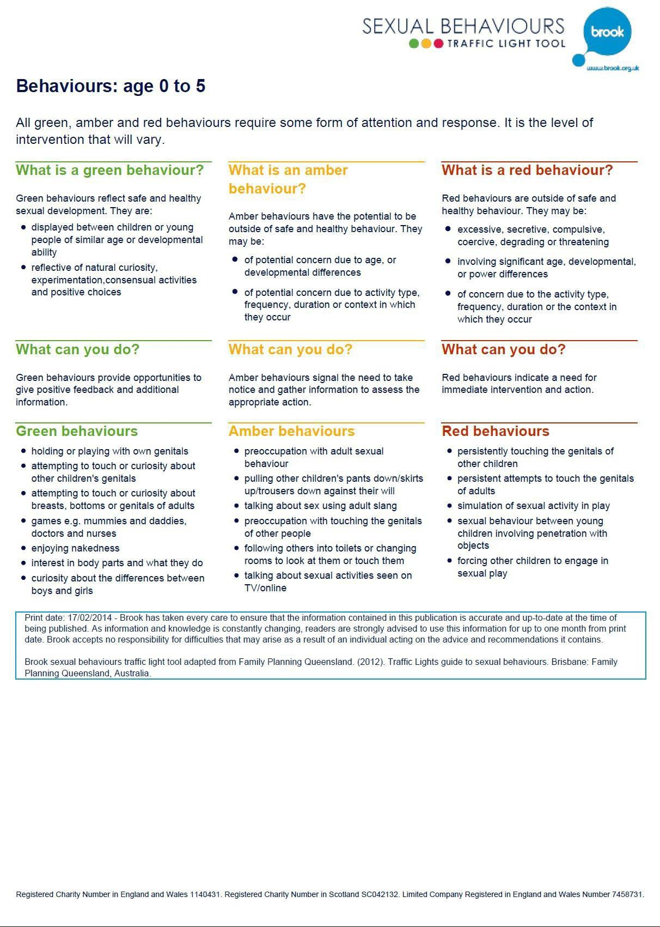

21 | P a g e

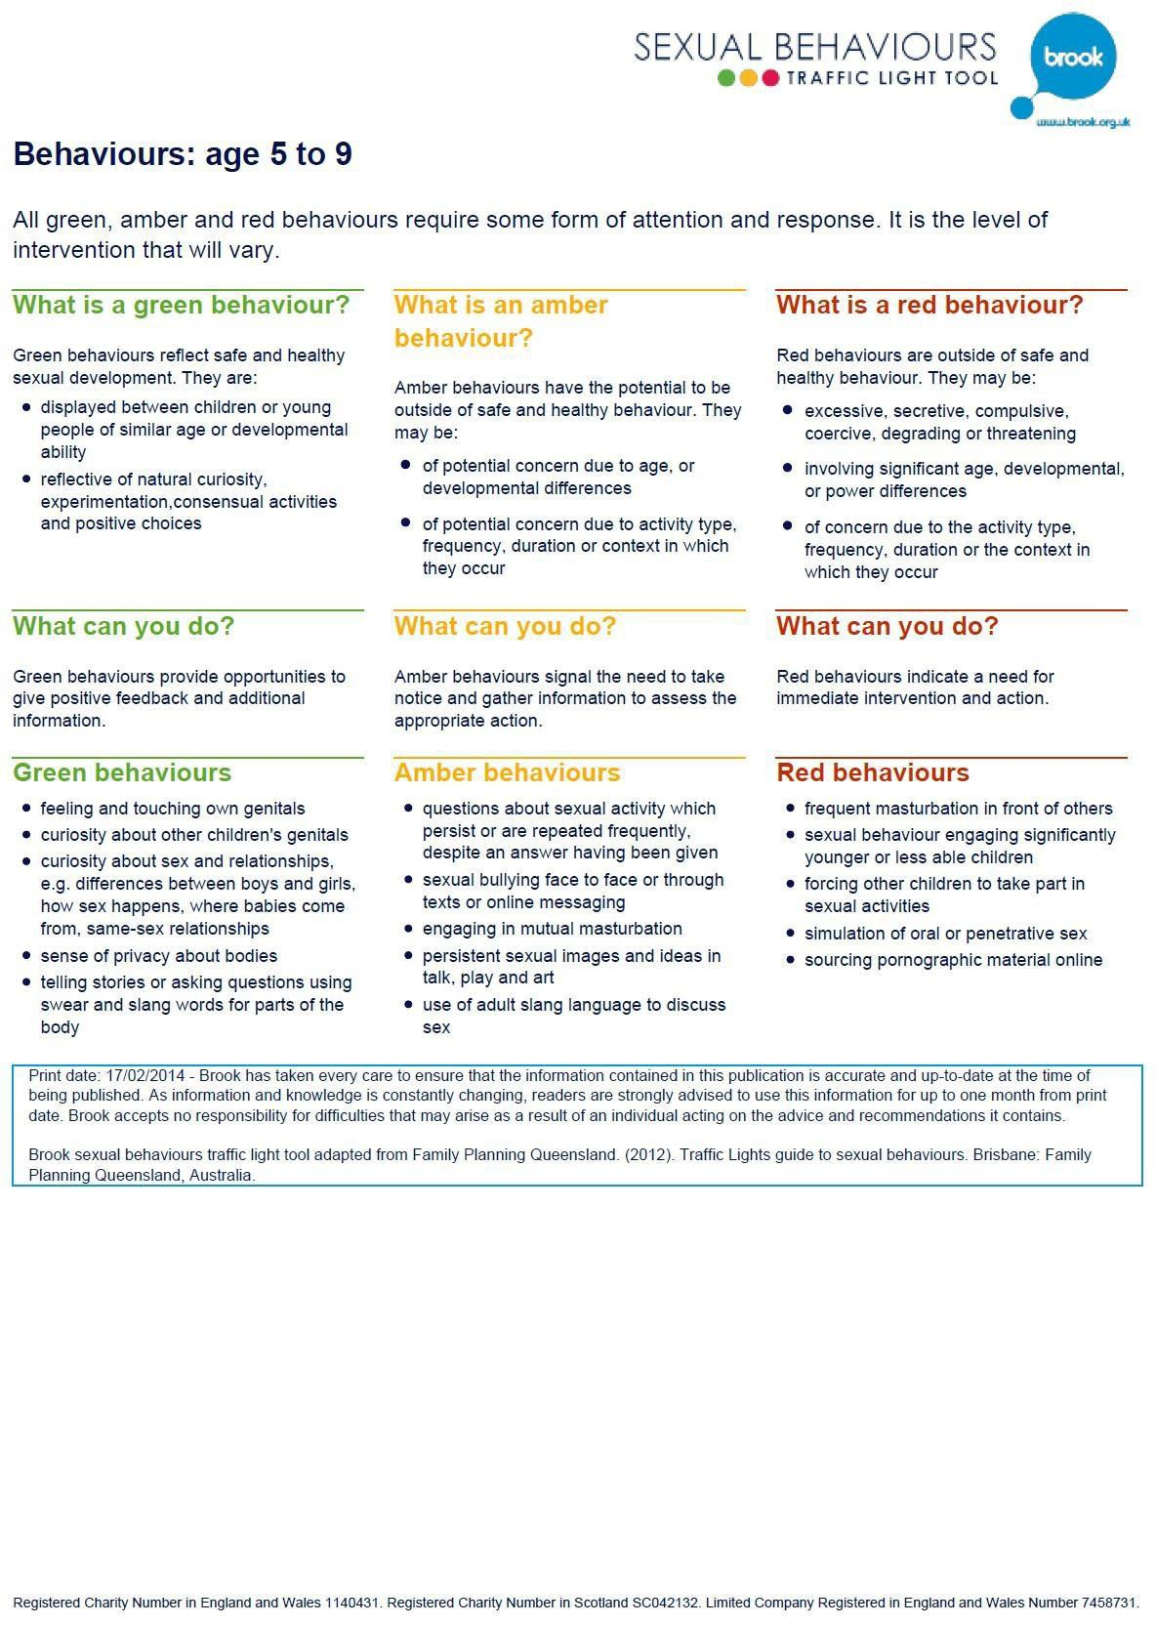

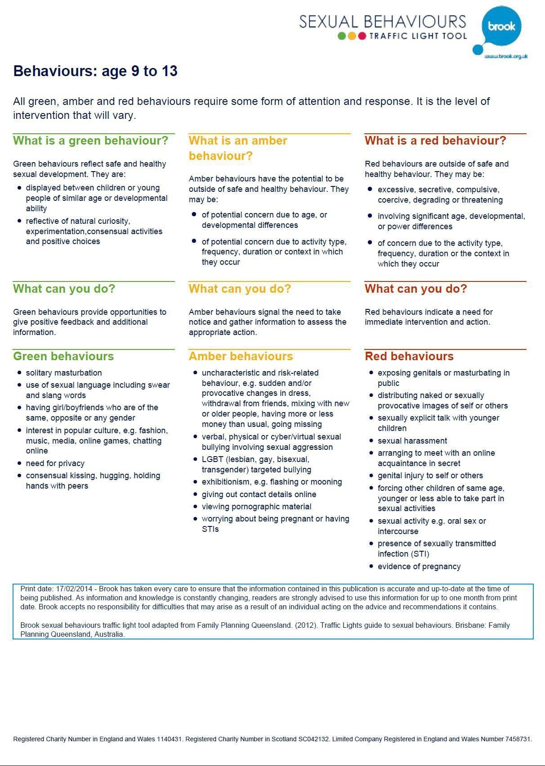

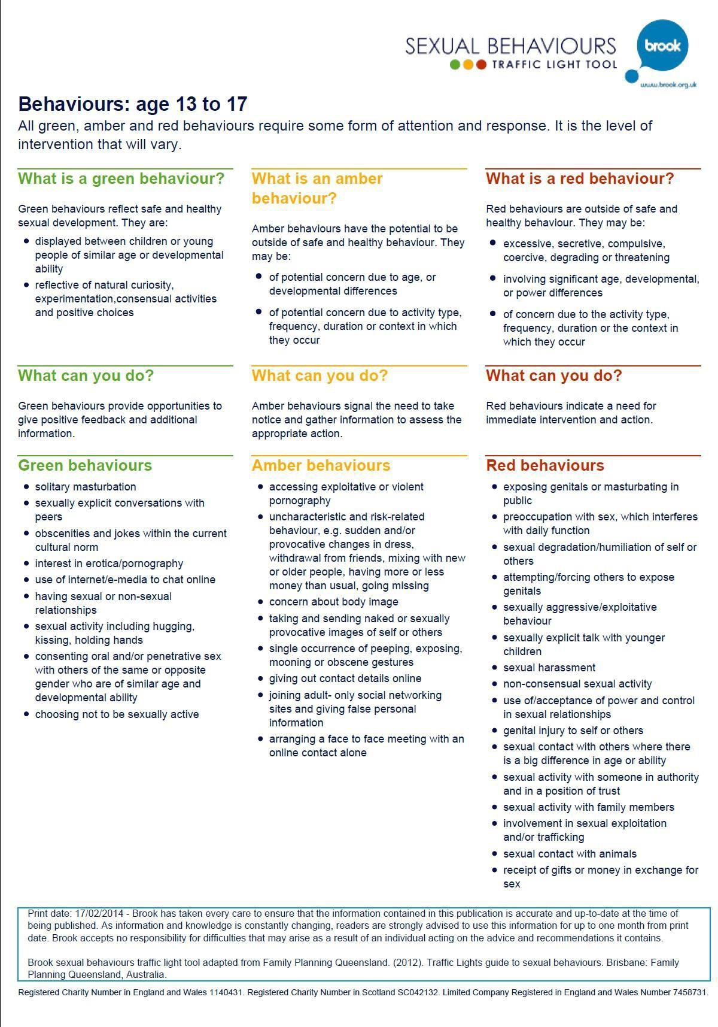

APPENDIX 2: CHECKLIST FOR UNDERSTANDING YOUNG PEOPLE WITH LEARNING DIFFICULTIES
Healthy Problematic Harmful
1. Type of sexual  activity. Use continuum in learning difficulties  research and | Normal sexual  behaviours | Low concern  behaviours and some Low to Medium concern behaviours | Low to Medium  concern behaviours. Medium to High concern behaviours and High concern  behaviours
2. Context of  behaviour | Mutual, both parties  free to engage and disengage | Behaviour infrequent/  isolated incident. Behaviour self- directed. Behaviour restricted to a specific setting | Behaviour is planned,  secretive, there are elements of force, threat or coercion  Previous concerns or convictions for sexual behaviour
3. Young Person’s  response | Happy, comfortable,  curious, may be embarrassed if found by adults | Embarrassment or  shame related to behaviour  They understand/ retain the reasons why others feel the behaviour is problematic/abusive  Experiences, consequences as significant/has some degree or awareness of consequences  Appears highly anxious or | Unclear as to the  consequences of sexual behaviour or they appear to have little meaning for them  Rejecting of concerns expressed

4. Response of  others | Happy, comfortable,  perhaps curious, may be embarrassed if found by adults | Uncomfortable or  irritated, not fearful or anxious  Feel able to tell someone | Uncomfortable, fearful,  anxious, avoidant of the young person
5. Relationship  between the young people | There should be no  significant differences in age or development which would suggest there is a power imbalance | One or two particular  young people targeted  Young person predominantly associates with children 3 or more years younger | Evidence of targeting  of those thought vulnerable  Power differences in the relationship  Poor social skills/ deficits in intimacy skills
6. Persistence of the  behaviour | Healthy interest but  not the sole focus of interest in the young person’s life | Responds to  complaints by stopping or changing behaviour  Intervention has some impact but | Evidence of a high  level of sexual compulsivity  Behaviours have  persisted despite significant negative

7. Other behavioural problems | No other behavioural problems, healthy peer relationships | No significant history of behavioural problems, generally positive relationships with peers  Access to others is well supervised  Or  Young person isolated in the community or has a very restricted lifestyle.  Access to others is poorly supervised | Concurrent diagnosis of significant mental health problems  Pattern of problematic sexual behaviours emerging in early childhood and continuing into adolescence  Viewed negatively in community due to sexual behaviours  History of fire setting  Long standing history of severely problematic or challenging behaviours
8. Background information known | No significant family history. Parents have a positive view of young person’s developing sexuality  Positive attachments with parents and carers  Young person has access to social and leisure pursuits  Young person has access to appropriate sex education | Family anxious about young person’s developing sexuality and have inappropriate concerns  Family experiencing high levels of stress  Siblings have experienced sexual abuse | Young person has experienced abuse, sexual, physical, emotional or neglect  Violence in the household  Members of family including siblings have a history of sexual offending  Poor or distorted sexual boundaries in the family  Patterns of discontinuity of care/poor attachments

Appendix 3: Multi-Agency Referral Form (MARF)
See Multi Agency Referral Form.

APPENDIX 4: Looked after children safety plan considerations

During each phase of intervention, it is necessary to consider and respond to a number of areas that could contribute to further sexual behaviours occurring. The Residential Safety Plan is a set of external controls and limits designed to help staff manage potential risk situations. This plan should be developed and reviewed by workers undertaking the assessment and intervention in collaboration with other relevant professionals. It should be formally reviewed in risk management meetings.

Careful consideration should be given as to how to communicate the safety plan with the child/ young person and how this can be incorporated in their own safety plan. It is important that the child/ young person receives positive messages about the plan and that positive behaviours are supported.

Name of child/young person: Date of birth: Name of Unit:
Key Worker: Manager:
Date Safety Plan agreed: Date of review:
1.Unit Occupancy
Who lives in the unit and what are their ages?

Who are regular visitors to the unit who could be in need of protecting? (include frequency of visits)

Does anyone else regularly care for this child / young person?
If so, other living environment safety plans will have to be considered.

2.Bedroomsand sleeping
What are the sleeping arrangements in the unit?
Rules required for bedroom and sleeping
Privacy and boundaries

Has problem sexual behaviours occurred in any of the bedrooms in the unit and if so what ones and when? How many staff are on duty on the night shift and is there waking staff?
What are the children and young people’s routines around going to bed, getting up? When do children and young people tend to go to sleep and how is this known?
Are there any rules for when someone is asleep? Are any bedrooms shared?
Are there locks on any of the bedroom doors and if so are they used, when and why? Are young people allowed in each other’s rooms and how is this decided?
Are there emergency beds?
Are children potentially exposed to sexualized behaviours of other children/
young people? Do any visitors go into bedrooms? Are bedroom doors open/ closed/ locked and how is this decided? Proximity of staff room to bedrooms
Can staff hear what is going on at night in different rooms?
Activity

Is there access to multimedia in the child/ young person’s bedrooms or any other bedrooms? If so are there any rules re access?
How do children/ young people spend time in bedrooms?
Dress Code
Is there a rule re night attire, dressing and undressing particularly in room sharing?

- Bathroom/toilet
Rules required about bathroom/toilet activities Privacy and Boundaries
Has any problem sexual behaviour occurred in the bathroom/toilet? If so, when and with whom? Has the bathroom/toilet/s got a working lock?
Who uses the lock and who doesn’t and are there any rules about this? Does anyone share the use of the bathroom?

Activity

If there are siblings do any older sibling help to bathe/toilet younger children? How long is spent in the bathroom?
Can staff hear what is going on in the bathroom from other rooms in the unit? Are children/young people up during the night to use the bathroom?

Dress code

What do children / young people wear to and from the bathroom?

- Sexualizationoftheenvironment

Rules required about sexuality of the environment Privacy and Boundaries
What is the unit’s policy on physical contact? What are staff’s views on intimacy and physical touch? What language is
tolerated/ not tolerated?
Do staff talk about sex or sexual acts in front of the children or to the children? Do the children/ young people touch each other in a sexualized way, and if so in what circumstances? Do the children/young people touch the staff ina sexualized way and if so in what circumstances?
Do the children / young people discuss sex and sexual behaviours with each other?
Is it possible for younger children to observe older young people engage in sexual behaviours?

Access to sexual images/materials

Do any of the child/young person’s behaviours include accessing pornography?
Is it possible for the child/young person to have pornographic magazines in the unit? What kind of access has the child/ young person to TV and the Internet?
What newspapers are regularly in the unit?
What posters are deemed acceptable /unacceptable?

7. Play and other activities outside the family hom
Where does the young person play/hang out with other young
people in the unit? Do staff always know the whereabouts of children/young people in the unit?
Are they allowed to play in bedrooms? How do staff know what they are doing?
Location
Activities

How does the young person spend his/her time in the unit? Who do they tend to associate most with and is this appropriate? Is there a lot of physical contact during play? Do friends come in to the unit?
How is it negotiated for friends to be in the unit?
What are the current levels of supervision and is this adequate?
6. Play and other activities in the unit

Activity
What clubs does the child/ young person attend? What activities are they involved in?
How much do they enjoy these activities?
Is the child/ young person vulnerable within these activities?
What is the layout of the building/grounds, and are there areas unsupervised? What rules and boundaries are currently inexistence? How are these monitored?
What are the consequences for breaking the rules?
Do the rules need consideration e.g. touch, bathroom activity, play, access to multi media?
How does the child/young person get to and from the activities? Are there rules needed about transport

People
Who attends the activities/ clubs with the child/ young person?
Who has responsibility for them on the way to and from the activity and during the activity? Do any other children/young people attend regularly or occasionally?
Are the age groups appropriate? What children may be vulnerable?
How do others react towards the child/ young person? What is the level of supervision and is this adequate?
Are all staff/ carers aware of the need for this level of supervision? Should any significant adults know about level of concern/risk?
If so how will this be managed?

8. StaffingandStructure
Staffing:
Have staff got all the information they need regarding the child/ young person How many staff are on each shift?
How is absence covered?
What staff need to be aware of the child/ young person’s behaviour and risk? Who is responsible for sharing information about the child/ young person and how is this done? Is the current level of supervision adequate?
Are all staff aware of the required level of supervision?
How is supervision managed at vulnerable times including: staff changeover; staff dealing with incidents involving other young people; movements between care and education
If the child/ young person has family contact how is this managed?
Do staff need to talk to the child/young person about their sexual behaviours?If yes, what preparation/level of support is required?

Structure:

In considering the layout of the unit and grounds are there particular “blind spots”? Is the unit close to any potential risk environments e.g. primary schools, nurseries etc.? Are there any other building issues to consider?

NO
YES
Are changes needing to be discussed at the next risk management review
8. Risk Management Reviews

APPENDIX5

SCHOOLSAFETY PLAN
During each phase of intervention, it is necessary to consider and respond to a number of areas that could contribute to further sexual behaviours occurring. The School Safety Plan is a set of external controls and limits designed to help school staff manage potential risk situations in the school environment. This plan should be developed and reviewed by workers undertaking the assessment and intervention in collaboration with school staff. It should be formally reviewed in risk management meetings.

Careful consideration should be given as to how to communicate the safety plan with the child/ young person and how this can be incorporated in their own safety plan. It is important that the child/ young person receives positive messages about the plan and that positive behaviours are supported.

Name of child/young person: Date of birth: Worker: School: School staff member: Date
Safety Plan agreed: Date of review:

1. Staffingandstructure
What staff are involved in teaching / supporting the child/ young person? Who is aware of concerns about their problem sexual behaviours?
Do other staff need to be made aware and if so how will this be managed? What is the current level of supervision and is this appropriate?
Is the level of supervision required achievable in the current circumstances? Are all staff aware of the level of supervision required?
Who is responsible for discussing the child/ young person‟ risk and needs to other staff?

Structure:

Are there areas within the school and grounds that are unsupervised? Are there any other building issues that may increase risk? e.g. building works, nursery or primary school located in same building, communal play ground

2. Intheclassroom

Rules required for the classroom:

Has the child/ young person engaged in any worrying sexual behaviours within the classroom setting now or previously?
If so what were the circumstances?
Who in the class may be vulnerable and why?
Is the level of supervision in the class adequate?
How much information does the class teacher and any others responsible for the child/ young person in the class have about the young person’s behaviours, risk and needs?
Is there particular time when the child/ young person seems more relaxed and content? Are there particular times or circumstances where the child/ young person seems unhappier/upset/ distracted/ irritable / distressed?
Can extra support / supervision be put in place during difficult times? Are the seating arrangements satisfactory?
Are there times when the child/ young person is allowed to leave the class during class times? Are there times when other adults are in the class besides the class teacher?
Is the classroom environment free of confusing sexual images and behaviours?
How is sex education managed and does the child/ young person need further information? Does the class teacher need to be able to talk to the child/ young person about their problem sexual behaviours?
If so what level of support will the teacher require?
Are there particular areas of risk in the class e.g. when the teacher is occupied with other pupils, and how can this be managed?

3.Times out with classroom structure
Have there been concerns about the child/ young person’s sexual behaviours in school out with the classroom?
If so who was the behaviours directed to and in what circumstances?
What children may be particularly vulnerable and how can this be managed?
What level of supervision is there when the child / young person is going between classes, at lunch and break times?
Is this adequate?
If more supervision is required how will this be achieved? Are particular rules required for going to the toilet?
Are there rules about showering, dressing and undressing for PE that need to
be considered? Are there rules about physical contact during play that need to be considered?
Is the environment free of confusing sexual messages, images and behaviours, e.g. access to computers, magazines etc.?
Are the right staff aware of the child’s level of supervision required? Has the child/young person a history of absconding?
Rules required morning, afternoon and lunch breaks:
Rules required for PE

- Risk Management Reviews

Are changes needing to be discussed the next risk management review YES
NO

If yes please identify changes needing to be discussed below:

School Risk Identification and Safety Plan

Name
Date of Safety Plan
Safeguarding Issue Identified | Possible Impact | Current Management Issues | Level of Risk Assessment of risk with current control measures in place |  |  | Additional Safeguarding Solutions | New Level of Risk Assessment of residual risk with all control measures in place. |  |  | Target Date | Review Date
 |  |  | Liklihood (probabili ty) | Impact (Severity) | Current Risk  Rating |  | Liklihood (probabili ty) | Impact (Severity) | Current Risk Rating

Signed _______________________________
Likelihood | High | 3 | 6 | 9
 | Medium | 2 | 4 | 6
 | Low | 1 | 2 | 3
 |  | Low | Medium | High
 | Impact

Appendix 6: Home Safety Plan

Safety Plan

During each phase of any manner of intervention it is necessary to consider and respond to a number of areas that could contribute to further sexual behaviours occurring. The Home Safety Plan is a set of external controls and limits designed to help parents/caregivers manage potential risk situations. This plan should be developed and reviewed by workers undertaking the assessment and intervention in collaboration with the family and other relevant professionals. It should be formally reviewed in risk management meetings.

Careful consideration should be given as to how to communicate the safety plan with the child/ young person and how this can be incorporated in their own keep safe plan. It is important that the child/ young person receive positive messages about the plan.

Name of child/young person: Date of birth:
Worker:

Parents / carers

Date Safety Plan agreed:

Date of review:

1. Home Occupancy
Who lives in the house and what are their ages?
Who are regular visitors to the home who could be in need of protecting?
(include frequency of visits)

Does anyone else regularly care for this child / young person in the family home?

2. Bedrooms and sleeping
Who sleeps where in the house?
Rules required for bedroom and sleeping

Privacy and boundaries

Guidance
- Have problem sexual behaviours occurred in any of the bedrooms in the house and if so what ones and when?
- What are the family routines around going to bed, getting up?
- When do family members tend to go to sleep and how is this known?
- Are there any rules for when someone is asleep?
- What are parent’s views about sharing beds/bedrooms?
- When do they think it is appropriate for children to sleep with adults, with a child of the opposite sex or with an older child?
- Are there locks on any of the bedroom doors and if so are they used, when and why?
- Are siblings allowed in each other’s rooms and how is this decided?
- Are children allowed in parent’s bedroom and how is this decided?
- Are children ever in the parental bedroom when they (parent’s/adults) have sexual intercourse?
- Are children potentially exposed to sexualised behaviours of older siblings?
- Do friends play in / hang out in bedrooms?
- Do other visitors go into bedrooms?
- Are bedroom doors open / closed / locked and how is this decided?

Activity

- Is there access to multimedia in the child / young person’s bedrooms or any other bedrooms? If so are there any rules re access?
- How do people spend time in bedrooms?
Dress Code -
Is there a rule re night attire, dressing and undressing particularly in room sharing situations?

3. Bathroom / toilet
Rules required about bathroom/toilet activities
Privacy and boundaries

Guidance
- Have any problem sexual behaviour occurred in the bathroom/toilet?
- If so, when and with whom?
- Has the bathroom/toilet/s got a working lock?
- Who uses the lock and who doesn’t and are there any rules about this?
- Do people share the bathroom at the one time, if so who tends to do this most often and what are parental views on sharing the bathroom?

Activity

  - Do any family members bathe/shower together and if so in what circumstances e.g. assistance to small children, sexual intimacy?
  - Do older siblings help to bathe/toilet younger children?
  - How long is spent in the bathroom?
  - Can parents hear what is going on in the bathroom form other rooms in the house?

Dress code
What do family members wear to and from the bathroom?

4. Family Nudity

Rules required about
nudity Privacy / boundaries

Guidance
- Are parent’s nude in front of each other, and if so who and in what context?
- Are parent’s nude in front of the children, and if so in what context?
- What are the parental views on adults being naked around children, children being naked around adults and children being naked around other children?
- Do any family members sleep in the nude?
- Is underwear worn around the house?

- Family Sexuality
Rules required about family sexuality Privacy / boundaries

Guidance:

A family’s sexuality is like an unwritten code from which family members understand acceptable and unacceptable ways of interacting with each other and with others out with the family. This covers privacy, intimacy and access to sexual information as well as sexual behaviours. This helps us understand the messages a child or young person has been given about sexuality. This is sensitive information to cover with families and this part of the safety plan is likely to evolve as workers develop closer relationships with families.

In considering the rules required about sexuality it may be helpful to consider the following:

Privacy and Boundaries
- What are parental views on intimacy and physical touch between adults in the house?
- Do parents kiss in front of the children?

- Do parents touch each other on breasts, bottom or crotch over or under clothes in front of the children?
- Do parents talk about sex or sexual acts in front of the children?
- Do the children touch each other in a sexualised way, and if so in what circumstances?
- Do the children touch the adults in a sexualised way and if so in what circumstances?
- Is there sexual innuendo?
  - Do any adult visitors touch each other in a sexualised way in front of the children?
  - Do adult visitors touch the children in a sexualised way?
  - Do the siblings discuss sex and sexual behaviours with each other?
  - Is it possible for younger children to observe older siblings engage in sexual behaviours with their partners?
  - If there are pets does any family member touch their sexual parts? Access to sexual images/materials
- Do any of the child/young person’s behaviours include accessing pornography?
- Are there pornographic magazines in the home and where are they kept and who has access to them?
- Are there pornographic videos/DVD’s and if so where are they kept and who has access to them?
- Has the child/young person unlimited access to TV?
- Has the child unlimited access to the internet?

6. Play and other activities in the family home
Rules required for play / other activities

Activities:

Guidance:
- How does the young person spend his/her time at home?
- How do the siblings spend their time together?
- What family activities do they do together?
- Is there a lot of physical contact during play?
- Do parents know when friends are in the house?
- How does the young person spend their time with friends in the house?
- How is it negotiated for friends to be in the family home?
Location:

Guidance:
- Where does the young person play/hang out with other siblings in the house?
- Where does the young person play/hang out with friends in the house?
- Are they allowed to play in bedrooms?
- How do the parents know what they are doing?
- What is the current level of supervision and is this adequate?
7. Play and other activities outside the family home

NO

If yes, please identify changes needing to be discussed below:
YES
Are changes needing to be discussed the next risk management review
8. Risk Management Reviews

APPENDIX 7:

COMMUNITY SAFETY PLAN

During each phase of intervention, it is necessary to consider and respond to a number of areas that could contribute to further sexual behaviours occurring. The Community Safety Plan is a set of external controls and limits designed to help parents/carers and workers manage potential risk situations out with the child/young person’s living environment. This plan should be developed and reviewed by workers undertaking the assessment and intervention in collaboration with the family and other relevant professionals. It should be formally reviewed in risk management meetings.

Careful consideration should be given as to how to communicate the safety plan with the child/ young person and how this can be incorporated in their own safety plan. It is important that the child/ young person receives positive messages about the plan and hat positive behaviours are supported.

Name of child/young person: Date of birth:
Worker:

Parents / carers
Date Safety Plan agreed: Date of review:

1.Activities in local neighbourhood
What activity is the child/young person involved in their local neighbourhood and who does this bring them into contact with?
ACTIVITY PEOPLE AGE

Rules required for local activities: Activity
People

2.Wider community
What activities are the child/ young person involved in and who does this bring them into contact with?

ACTIVITY PEOPLE AGE
Rules required for community activities

Has problem sexual behaviours occurred in the child/ young person’s current locale either outside or in neighbours homes?
If so where and in what circumstances did the behaviour occur? In previous living environments have behaviours occurred in neighbourhood? If yes, where and in what circumstances?
How does the child/young person spend their time in the local neighbourhood? Are there particular things they are fond of doing?
Are there particular activities that increase emotional arousal? Are they in other people’s houses?
What is in the local neighbourhood e.g. parks, schools What is the lay out like and where can be seen
from where they live? What level of supervision is there, and is this adequate?
What rules are there for playing out and going into other people’s houses? What activities do they engage in?
How is their access to multimedia monitored in other people’s houses?

Appendix 8 - Case Formulation & CBT
Predisposing factors which make them vulnerable to the problem:

Precipitation factors which triggered the problem:

Presenting problems:

Protective Factors:

Perpetuating factors that keep the problem going:

HSB Intervention Plan

Aim & Method | Who | When | What is the intended outcome

