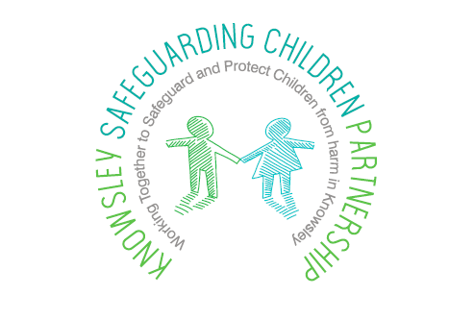

Keeping children safe from abuse

The recent events that have unfolded as a result of the Coronavirus pandemic has resulted in extraordinary measures being put in place at national and local levels to reduce the risk to our communities.

The current ‘lock down’, has highlighted a potential increased risk to children who may be vulnerable to different forms of abuse. This includes witnessing domestic abuse, suffering physical violence or at risk of sexual abuse, particularly on-line grooming given the restrictions around leaving the home.

This document has been prepared to provide advice to parents, carers or anyone who may have concerns about a child, to help you spot the signs of abuse and what to do if you are worried about a child.

Spotting the signs of abuse
The current measure in place can cause stress, anxiety and changes in everyone's behaviour. It can therefore be difficult to know for certain if something is wrong.
Some of the signs you may spot include:

- aggressive or repeated shouting
- hearing hitting or things being broken
- children crying for long periods of time
- very young children left alone or are outdoors by themselves
- children looking dirty or not changing their clothes
- Children being withdrawn or anxious.

These signs do not necessarily mean that a child is being abused, but you may wish to seek advice.

Keep your child safe online
It is important to have regular conversations about staying safe online and to encourage children to speak to you if they come across something worrying online.

There are support mechanisms in place to provide guidance for parents and carers to keep children safe online. They will, support you to talk to your child about a range of online safety issues, set up home filtering in a child-friendly way and set up age-appropriate parental controls on digital devices. These include;
- Thinkuknow - provides resources for parents and carers and children of all ages to help keep children safe online
- Childnet has developed guidance for parents and carers to begin a conversation about online safety, as well as guidance on keeping under-fives safe online
- Parent Info providing support and guidance for parents and carers related to the digital world from leading experts and organisations
- NSPCC has guidance for parents and carers to help keep children safe online
- UK Safer Internet Centre provides tips and advice for parents and carers to keep children safe online - you can also report any harmful content found online through the UK Safer Internet Centre

Reporting your concerns
If your child has been a victim of child sexual abuse – online or offline – and you believe they are in immediate danger, you should call 999 and ask for the police. The police will continue to respond to emergency calls.

If you are concerned that your child has been a victim of online sexual abuse or you are worried about the way someone has been communicating with your child online, you can report it to National Crime Agency-CEOP (Child Exploitation and Online Protection).

If you have concerns about your own or another child’s safety, you can contact the NSPCC helpline (0808 800 5000) for support and advice –
The Together, we can tackle child abuse campaign also provides information on the signs of child abuse and neglect

