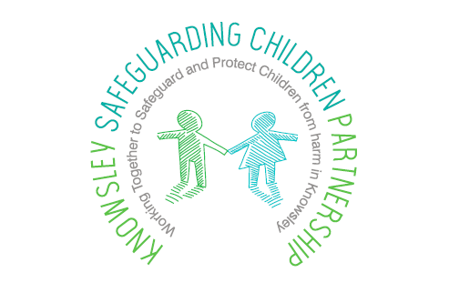

Child Safeguarding practice reviews
Notifiable incidents process guidance

Serious child safeguarding case review process – key stages
The following stages will be followed on receipt of information that a case may be appropriate for a serious child safeguarding review

Stage 1 - Reporting of a notifiable incident
The local authority should report any incident that meets the criteria of a notifiable incident, to Ofsted and the relevant LSCP or LSCPs promptly, and within five working days of becoming aware that the incident has occurred.

Criteria for Notifiable Incidents

A notifiable incident is an incident involving the care of a child which meets any of the following criteria:

- A child has died (including cases of suspected suicide), and abuse or neglect is known or suspected;
- A child has been seriously harmed and abuse or neglect is known or suspected;
- A looked after child has died (including cases where abuse or neglect is not known or suspected); or
- A child in a regulated setting or service has died (including cases where abuse or neglect is not known or suspected).

The local authority should report any incident that meets the above criteria to Ofsted and the relevant LSCB or LSCBs promptly, and within five working days of becoming aware that the incident has occurred.

Stage 2 - Reporting an incident for consideration of a serious case
review
Notification of an incident that fits the criteria for a serious child safeguarding review, which is received from children’s social care or a partner agency, will be brought to the attention of the LSCP Business Unit.

The practitioner making the referral will submit a referral form, which will be forwarded to the LSCP Business Manager.

Criteria for serious child safeguarding review
Where a local authority in England knows or suspects that a child has been abused or neglected, KSCP will notify the Child Safeguarding Practice Review Panel ( the panel) if;–

- the child dies or is seriously harmed in the local authority’s area, or
- While normally resident in the local authority’s area, the child dies or is seriously harmed outside England.

Stage 3 -Initial assessment process (day 1)
The LSCP Business Manager will facilitate a triage process in consultation with the Chair of the Rapid Review Group and a nominated professional. They will consider whether the case meets the criteria for a serious child safeguarding review, notification to the national panel.

If in their opinion the case does meet the criteria, they will recommend to the Chair of the local safeguarding children partnership that a rapid review of the case is required.

A written record of the decision to undertake a rapid review will be made by the Chair of the local safeguarding children partnership.
The aim of this rapid review is to enable safeguarding partners to:

- Gather the facts about the case, as far as they can be readily established at the time
- Discuss whether there is any immediate action needed to ensure children’s safety and share any learning appropriately.
- Consider the potential for identifying improvements to safeguard and promote the welfare of children.
- Decide what steps they should take next, including whether or not to undertake a child safeguarding practice review

Stage 4 – case summaries (Day 2)
The LSCP will circulate an ‘initial scoping and information sharing’ case summary document to be completed by the relevant agencies who will summarise their involvement with the child and highlight any significant information, which may assist the Rapid Review Panel in their assessment.

The case summaries will be completed and returned to the KSCP Business Unit within 5 days

Stage 5 – convening the panel (day 8)
The Business Unit will collate the case summaries and circulate the documents to members of the panel, which will enable them to make an informed decision.

Stage 6 – Rapid Review Panel (day 10)
The multi-agency panel will be drawn from members of a standing panel identified as senior Managers who have no direct involvement in the case.

The Rapid Review Group must include representatives from the local authority, health, Police and Education. (key partners).

There should also be legal representative to provide advice and guidance to ensure that the panel comply with any legislative requirements.

The Rapid Review Group will review the information from the case and make one of the following recommendations to the Chair of the local safeguarding children partners;
- a National Safeguarding Practice Review to be Undertaken
- for a Local Safeguarding Practice Review to be Undertaken
(Independent Author)
- for a multi-agency practice learning review to be Undertaken
(local reviewer)
- for a single agency practice learning to be undertaken
(local reviewer)
- no review required but any local learning will be identified
Stage 7 – Authorised decision maker (Day12)
The Chair of the Rapid Review Group will submit the recommendations of the panel to the Chair of the local safeguarding children partners for a decision on how to progress the case.

The Chair of the LSCP will write to the national Child Safeguarding Practice Review Panel to appraise them of the rapid review and the decision.

If the Rapid Review Group have determined that a local review will be carried out, they should inform the National Panel, DfE and Ofsted within 15 working days from notification to the LSCP.

